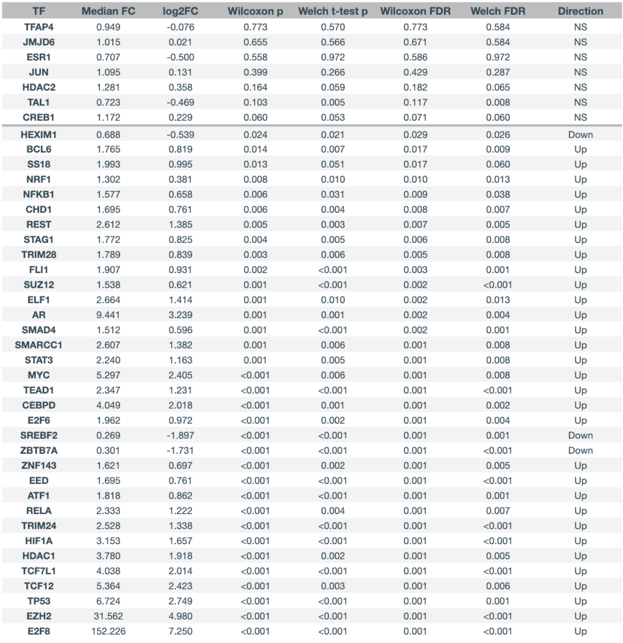
Table S1. Full differential expression results for transcription factors shown in Fig. 3.
Median FC, log₂FC, Wilcoxon rank-sum p-value, Welch’s t-test p-value, Wilcoxon FDR correction, Welch FDR correction, and directionality are presented for the 41 transcription factors. The TFs are organized by descending Wilcoxon p-value; the bolded line between CREB1 and HEXIM1 separates the nonsignificant Wilcoxon p-values (upper half) from the significant (lower half).

Abbreviations: FC, fold change; FDR, false discovery rate; ATF1, activating transcription factor 1; CEBPD, CCAAT/enhancer-binding protein delta; CHD1, chromodomain helicase DNA binding protein 1; CREB1, cyclic AMP responsive element binding protein 1; E2F6, early region 2 transcription factor 6; E2F8, early region 2 transcription factor 8; EED, embryonic ectoderm development; ELF1, E74 like ETS transcription factor 1; ESR1, estrogen receptor 1; EZH2, enhancer of zeste 2 polycomb repressive complex 2 Subunit; FLI1, fli-1 proto-oncogene, ETS transcription factor; HDAC1, histone deacetylase 1; HDAC2, histone deacetylase 2; HEXIM1, HEXIM P-TEFb complex subunit 1; HIF1A hypoxia inducible factor 1 subunit alpha; JMJD6, jumonji domain containing 6, arginine demethylase and lysine hydroxylase; JUN, jun proto-oncogene, AP-1 transcription factor subunit; NFKB1, nuclear factor kappa B subunit 1; NRF1, nuclear respiratory factor 1; RELA, RELA proto-oncogene, NF-kB subunit; REST, RE1 silencing transcription Factor; SMAD4, SMAD family member 4; SMARCC1, SWI/SNF related BAF chromatin remodeling complex subunit C1; SS18, SS18 subunit of BAF chromatin remodeling complex; STAG1, STAG1 cohesin complex component; STAT3, signal transducer and activator of transcription 3; SUZ12, SUZ12 polycomb repressive complex 2 subunit; TAL1, TAL bHLH transcription factor 1, erythroid differentiation factor; TCF7L1, transcription factor 7 like 1; TEAD1 TEA domain transcription factor 1; TFAP4, transcription factor AP-4;; TRIM24, tripartite motif containing 24; TRIM28, tripartite motif containing 28; ZNF143, zinc protein 143.

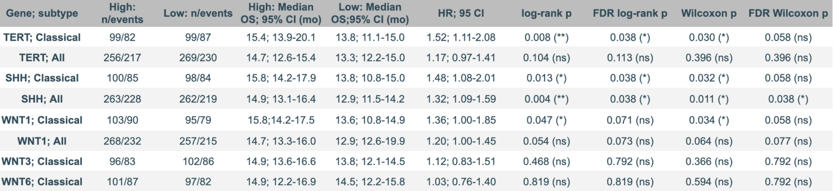

Table S2. Full survival analysis statistical values of TERT, SHH, and WNT genes (1, 3, and 6) stratified by molecular subtype.
Kaplan-Meier analysis for TERT, SHH, WNT1, WNT3, and WNT6 expression in GBM patients from TCGA_GBM HG-U133A data, stratified by molecular subtypes (Classical and All/Combined subtypes). For each gene and subtype pair, the table reports sample size and number of events (n/events) of both the high and low expression groups; median OS with 95% CI (mo, months), hazard ratio (HR) with 95% CI, log-rank p-value, and Gehan-Breslow-Wilcoxon p-value, and corresponding Benjamini-Hochberg-FDR corrected p-values were also included. Significance was reported as follows: **p<0.01, *p<0.05, ns=not significant (p or FDR-adjusted p>0.05). Hazard ratios (HR > 1) indicate poorer survival in the high expression group.
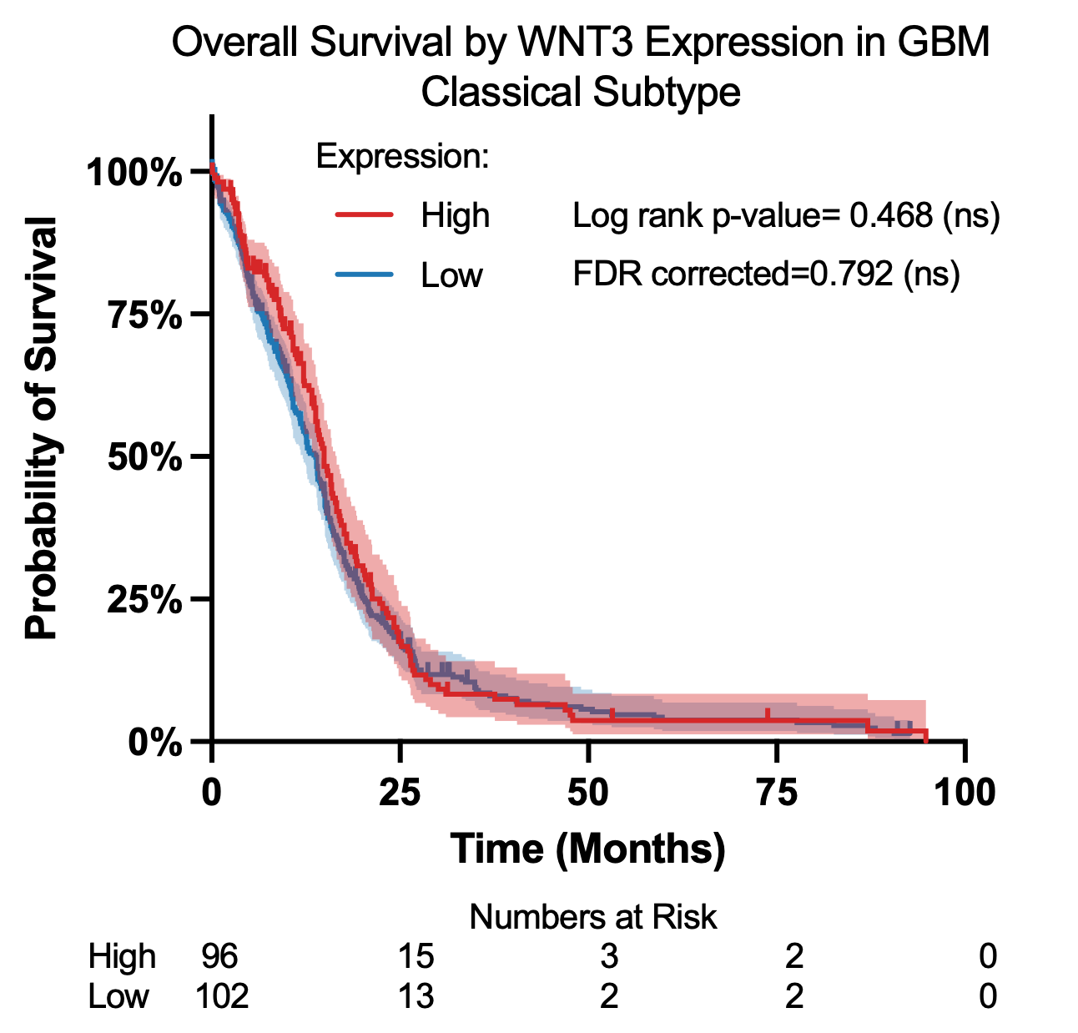  A | 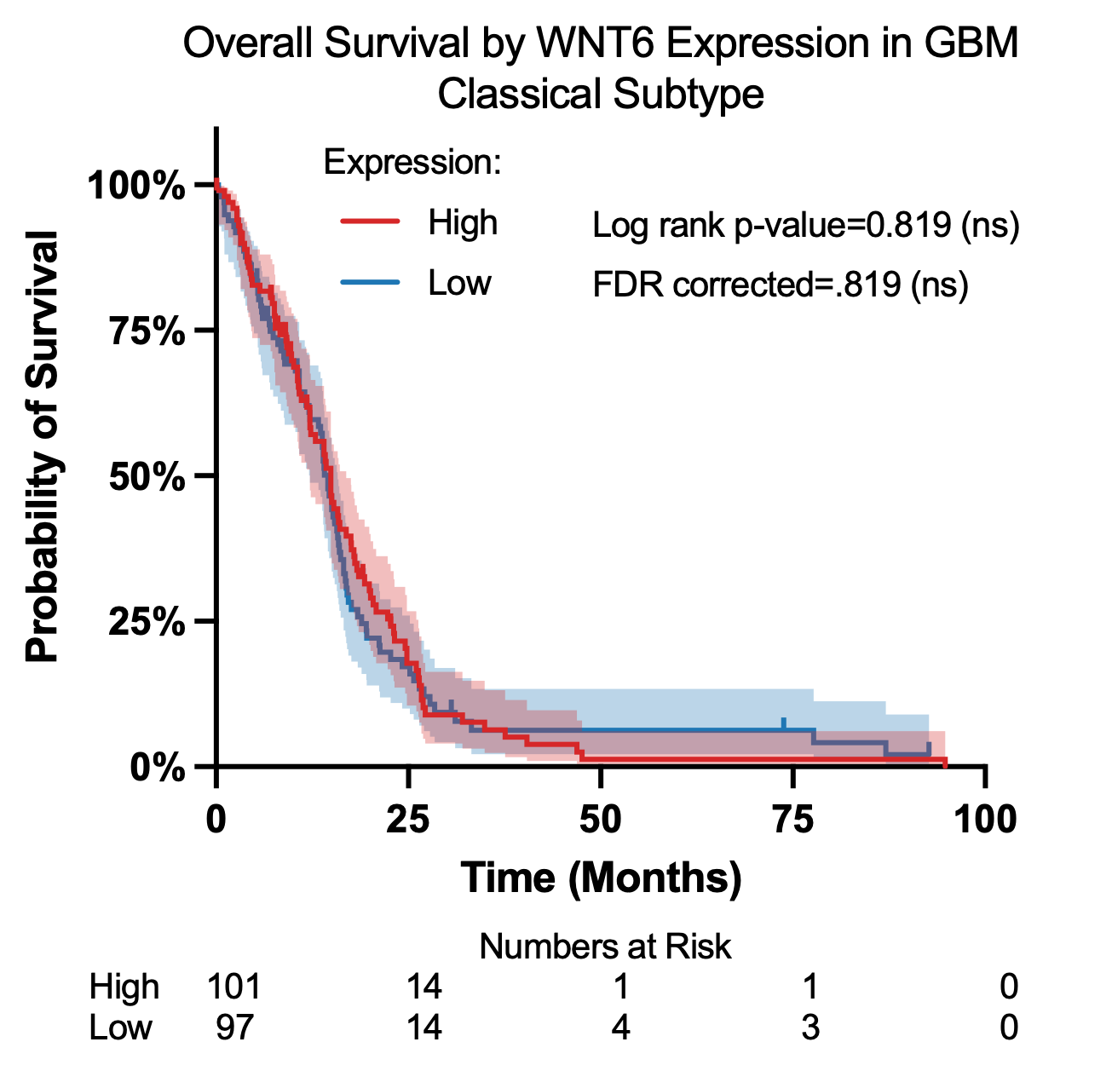  B

Fig S1. WNT3 and WNT6 Kaplan-Meier survival estimator stratified by gene expression in the classical subtype
[A-B] Kaplan-Meier survival curves comparing patients with high (red) and low (blue) expression of WNT3 and WNT6 using TCGA_GBM HG-U133A data. Statistical significance was evaluated using log-rank tests (p<0.05 was considered significant). Events, group sizes (n), HRs, 95% CIs for HRs, median OS, 95% CIs for median OS, and Gehan-Breslow-Wilcoxon p-values are shown in Table S2.
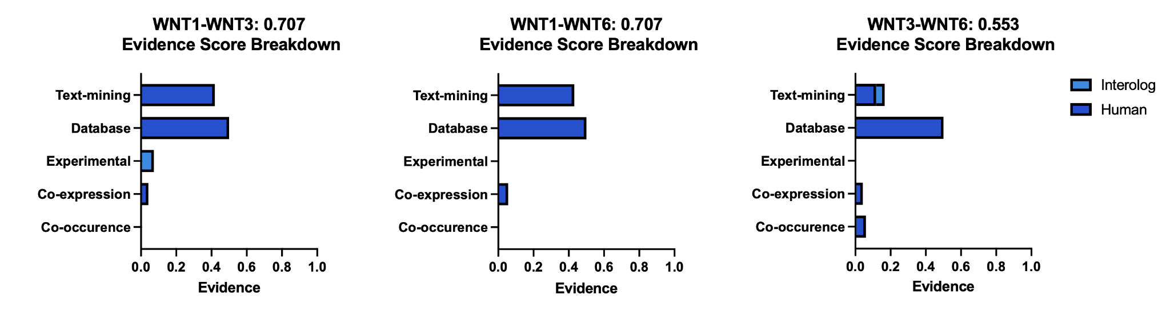
Fig S2. STRING WNT1-WNT3-WNT6 association evidence decomposed.
The confidence score in the titles is the combined evidence suggesting a correlative link, which is further decomposed by the bar graph into: text-mining, database, experimental, co-expression, and co-occurrence-based evidence

