Title: Supplementary Information: Reinforcement Learning Inside a Closed Game Platform: Combat NPCs Trained and Evaluated Entirely Within Roblox
Authors: Micah Zhou¹*, Weipeng Nie²
¹Dublin High School; Dublin, United States.
²King's College London; London, United Kingdom.
*Corresponding author.
Supplement to "Reinforcement Learning Inside a Closed Game Platform: Combat NPCs Trained and Evaluated Entirely Within Roblox". Tables and algorithms referenced from the main text. Numbering is independent of the main text. Every item is cited there at the point it supports.
---
Supplementary Table S1: Exclusion accounting for the replicated runs
Supplementary Table S1 | Exclusion accounting for the replicated runs. Every pair episode the parser produced across the 180 evaluation windows of the two replicated arms. Clear-start pair episodes are out of scope by design rather than excluded: the fixture bank contains both blocked and clear starts, and only blocked starts test recovery. The sub-second column is retained at zero to record that the rule was checked rather than skipped. Under the fixture bank a respawn-boundary fragment cannot arise, because every encounter begins from a fixed fixture.
Architecture | Checkpoint | Windows | Pair episodes parsed | Clear-start (out of scope) | Blocked-start | Excluded: sub-second | Excluded: other | Clean blocked-start | Open at cutoff
Flat-joint | 30 min | 18 | 225 | 110 | 115 | 0 | 0 | 115 | 12
Flat-joint | 45 min | 18 | 275 | 126 | 149 | 0 | 0 | 149 | 14
Flat-joint | 60 min | 18 | 328 | 137 | 191 | 0 | 0 | 191 | 14
Flat-joint | 90 min | 18 | 432 | 165 | 267 | 0 | 0 | 267 | 14
Flat-joint | 120 min | 18 | 280 | 120 | 160 | 0 | 0 | 160 | 15
Factored dual-head | 30 min | 18 | 329 | 138 | 191 | 0 | 0 | 191 | 11
Factored dual-head | 45 min | 18 | 220 | 107 | 113 | 0 | 0 | 113 | 13
Factored dual-head | 60 min | 18 | 212 | 103 | 109 | 0 | 0 | 109 | 10
Factored dual-head | 90 min | 18 | 297 | 126 | 171 | 0 | 0 | 171 | 12
Factored dual-head | 120 min | 18 | 240 | 112 | 128 | 0 | 0 | 128 | 12
Total | all | 180 | 2,838 | 1,244 | 1,594 | 0 | 0 | 1,594 | 127

No pair episode was excluded from the replicated matrix. Twenty-seven evaluation windows were aborted during collection, by a platform disconnection, a tooling fault or a run that had to be restarted. An aborted window writes neither a ledger row nor a parsed file and was re-run in full, so only the re-run appears in this table and no partial window is either silently included or silently dropped. The difference between this accounting and the first panel is a property of the protocol, not of the models: the fixture bank removes by construction the respawn-boundary fragments that had to be excluded by hand from the original runs.
---
Supplementary Table S2: Conventional combat metrics, replicated runs
Supplementary Table S2 | Conventional combat metrics for the replicated runs. Pooled over the six runs of each architecture and descriptive only: pooling weights the higher-yield runs more heavily, and a run yields more pair episodes precisely when it ends encounters faster, so the pooled recovery rate in this table is not the run-level mean of Tables 6 and 7 and the two are not expected to agree. Every inferential figure in this paper is run-level. This table is reported for comparability with conventional game-AI reporting. No-kill here includes pair episodes still open at the window cutoff as well as stalemates, unlike Table 10 in the main text, which counts only closed pair episodes. Time to first hit is measured on the clear-start pair episodes of the same windows.
Architecture | Checkpoint | Pair episodes | Swings | Hits (hit rate) | Kills NPC-1 / NPC-2 / no kill | Median duration (s) | NPC-1 recovery (pooled) | Any-side (pooled) | Clear-start median time to first hit (s)
Flat-joint | 30 min | 115 | 876 | 792 (90.4%) | 21 / 30 / 64 | 90.0 | 48.7% | 48.7% | 2.0
Flat-joint | 45 min | 149 | 1,165 | 1,099 (94.3%) | 41 / 35 / 73 | 90.0 | 53.0% | 53.7% | 2.0
Flat-joint | 60 min | 191 | 2,170 | 1,953 (90.0%) | 71 / 63 / 57 | 15.7 | 61.8% | 71.2% | 2.0
Flat-joint | 90 min | 267 | 3,785 | 3,546 (93.7%) | 95 / 106 / 66 | 10.6 | 76.0% | 76.0% | 2.0
Flat-joint | 120 min | 160 | 1,950 | 1,809 (92.8%) | 43 / 59 / 58 | 16.5 | 65.6% | 65.6% | 2.0
Factored dual-head | 30 min | 191 | 1,955 | 1,840 (94.1%) | 25 / 122 / 44 | 12.7 | 35.1% | 79.6% | 2.0
Factored dual-head | 45 min | 113 | 1,083 | 980 (90.5%) | 23 / 38 / 52 | 74.6 | 60.2% | 62.8% | 2.0
Factored dual-head | 60 min | 109 | 931 | 782 (84.0%) | 33 / 16 / 60 | 90.0 | 50.5% | 51.4% | 1.0
Factored dual-head | 90 min | 171 | 2,261 | 1,947 (86.1%) | 66 / 52 / 53 | 14.7 | 70.2% | 70.8% | 2.0
Factored dual-head | 120 min | 128 | 1,109 | 1,059 (95.5%) | 52 / 17 / 59 | 16.5 | 59.4% | 60.2% | 2.0

Two patterns in this panel bear on the argument. The hit rate is high and nearly flat across every cell (between 84.0% and 95.5%), while pooled recovery moves between 35.1% and 76.0% and the median encounter length moves between 10.6 and 90.0 s. A policy that never gets around the cover still connects with most of the swings it does take, which is why the hit rate cannot stand in for the encounter-level metric. The 30-min factored dual-head cell shows the side asymmetry of Table 4 in its combat counts as well: NPC-2 records 122 kills against NPC-1's 25, and pooled NPC-1 recovery is 35.1% against an any-side figure of 79.6%.
---
Supplementary Table S3: Recovery chain progress
Supplementary Table S3 | Progress of NPC-1 along the blocked-start chain. Share of clean blocked-start pair episodes that ever reached each stage, with the median time at which those that reached it first did so. A pair episode that never reaches a stage counts in the denominator of the share but not in the median. The first stage, a movement other than Hold, is reached in 100.0% of pair episodes at a median of 0.0 s in every cell and is omitted from the table. Stages are cumulative in intent but measured independently, so a later stage can exceed an earlier one where a pair episode arrives at it by another route.
Architecture | Checkpoint | Pair episodes | Clear LOS % | In range % | Swing % | Hit % | Clear LOS med (s) | In range med (s) | Swing med (s) | Hit med (s)
Flat-joint | 30 min | 115 | 58.3% | 87.8% | 50.4% | 48.7% | 1.9 | 1.6 | 2.6 | 3.0
Flat-joint | 45 min | 149 | 57.7% | 91.9% | 53.7% | 53.0% | 2.0 | 1.4 | 3.7 | 4.0
Flat-joint | 60 min | 191 | 75.4% | 92.7% | 62.3% | 61.8% | 2.7 | 1.5 | 3.9 | 4.1
Flat-joint | 90 min | 267 | 79.8% | 92.1% | 77.2% | 76.0% | 2.0 | 1.5 | 3.3 | 3.9
Flat-joint | 120 min | 160 | 75.6% | 91.9% | 66.2% | 65.6% | 2.9 | 1.5 | 3.9 | 4.0
Factored dual-head | 30 min | 191 | 82.7% | 94.2% | 37.2% | 35.1% | 2.7 | 1.4 | 4.1 | 4.1
Factored dual-head | 45 min | 113 | 71.7% | 92.0% | 61.1% | 60.2% | 2.5 | 1.4 | 3.3 | 3.0
Factored dual-head | 60 min | 109 | 57.8% | 86.2% | 53.2% | 50.5% | 1.8 | 1.4 | 3.2 | 3.0
Factored dual-head | 90 min | 171 | 75.4% | 91.8% | 71.3% | 70.2% | 2.3 | 1.4 | 3.7 | 4.0
Factored dual-head | 120 min | 128 | 65.6% | 89.8% | 59.4% | 59.4% | 2.0 | 1.4 | 2.8 | 3.0

The chain locates where recovery is lost, and it is not at the same place in the two arms. Reaching sword range is almost never the obstacle: between 86.2% and 94.2% of blocked-start pair episodes get there, in every cell, at a median of about 1.4 to 1.6 s. What separates the cells is the two stages on either side of it. Regaining line of sight is reached in 57.7% to 82.7% of pair episodes, and swinging in 37.2% to 77.2%. The 30-min factored dual-head checkpoint is the clearest case: 82.7% of its pair episodes regain line of sight and 94.2% reach range, the highest of any cell on both counts, yet only 37.2% ever swing. This is the navigation-without-attack pattern that accounts for 46% of that cell's pair episodes, visible here as a 45-point gap between arriving and attacking. In every cell the share that lands a hit is within 3 points of the share that swings, so once a swing is taken it usually connects. The failures are failures to regain sight or to attack, not failures of the attack itself.
---
Supplementary Table S4: Architecture difference, continued-training change and interaction, with intervals
Supplementary Table S4 | Architecture difference, continued-training change and their interaction, with 95% intervals on run means. The estimand at each checkpoint is the mean over the six runs of the run rate (three windows pooled within the run) for each architecture, and the difference factored dual-head minus flat-joint in percentage points. Intervals are exhaustive percentile bootstraps with the two arms resampled independently (6⁶ × 6⁶ ordered draws, frozen endpoint convention). The exact permutation p is the test already reported in the main text and is shown for continuity. Each interval is attached to the difference of run means at that one checkpoint. The five intervals are pointwise and do not form a confidence band around a curve. Every interval crosses zero and is listed as such. At n = 6 per arm an interval that crosses zero is not evidence of equivalence or of non-inferiority. Panel (b) gives the within-run change from 60 to 120 min for each architecture, paired within run with the six runs resampled. Panel (c) gives the interaction, the factored change minus the flat change.
(a) Architecture difference per checkpoint
Checkpoint | n flat / n factored | Flat-joint mean | Factored dual-head mean | Factored - flat (pp) | 95% interval (pp) | p (exact permutation, two-sided)
30 min | 6 / 6 | 51.0% | 42.8% | -8.2 | [-37.0, +19.2] | 0.604
45 min | 6 / 6 | 53.5% | 53.0% | -0.5 | [-26.9, +23.9] | 0.978
60 min | 6 / 6 | 58.0% | 48.7% | -9.3 | [-36.3, +17.5] | 0.556
90 min | 6 / 6 | 62.4% | 63.4% | +0.9 | [-26.2, +25.4] | 0.950
120 min | 6 / 6 | 55.8% | 50.4% | -5.3 | [-39.6, +30.3] | 0.803

(b) Within-run change, 60 to 120 min
Architecture | Mean change (pp) | 95% interval (pp) | Runs up / down / unchanged
Flat-joint | -2.2 | [-32.1, +28.4] | 2 / 4 / 0
Factored dual-head | +1.7 | [-34.9, +36.8] | 3 / 3 / 0

(c) Architecture × horizon interaction
Contrast | Factored change - flat change (pp) | 95% interval (pp) | p (exact permutation, two-sided)
60 to 120 min | +3.9 | [-44.5, +51.0] | 0.885

The intervals describe small-sample uncertainty across independent training runs. They are wide because six runs per arm is few, and their width is the finding. The point estimates and permutation p-values are the same numbers as in the main text. Only the intervals are new here.
---
Supplementary Table S5: NPC-1 recovery by occluder type, descriptive
Supplementary Table S5 | NPC-1 recovery split by the occluder that blocked NPC-1 at the start, descriptive only. Clean blocked-start pair episodes from the regular evaluation windows of the replicated runs, split into two start classes by the blocking occluder: a straight wall or a U-shaped cover. In every window the two classes add back exactly to the pair-episode and recovery counts of the run ledger. Pooled rate is all pair episodes in the cell over the six runs. Run mean is the equal-weight mean of the per-run rates over the runs that contribute at least one pair episode, and every cell has all six. No test and no interval are given, and none should be read in: the two start classes differ at the same time in occluder shape, position, starting distance and fixture composition, so a difference between the two rows of a cell is not an effect of occluder shape, and nothing in this table speaks to maps other than the one used here.
Architecture | Checkpoint | Occluder | Pair episodes (pooled) | NPC-1 recovered | Pooled rate | Run mean | Runs with pair episodes | Pair episodes per run (min–max)
Flat-joint | 30 min | straight wall | 61 | 29 | 47.5% | 49.4% | 6 / 6 | 2–13
Flat-joint | 30 min | U-shaped cover | 54 | 27 | 50.0% | 50.0% | 6 / 6 | 9–9
Flat-joint | 45 min | straight wall | 85 | 43 | 50.6% | 54.0% | 6 / 6 | 8–21
Flat-joint | 45 min | U-shaped cover | 64 | 36 | 56.2% | 55.3% | 6 / 6 | 9–17
Flat-joint | 60 min | straight wall | 102 | 69 | 67.6% | 64.1% | 6 / 6 | 12–21
Flat-joint | 60 min | U-shaped cover | 89 | 49 | 55.1% | 48.7% | 6 / 6 | 9–25
Flat-joint | 90 min | straight wall | 125 | 98 | 78.4% | 61.7% | 6 / 6 | 3–46
Flat-joint | 90 min | U-shaped cover | 142 | 105 | 73.9% | 60.4% | 6 / 6 | 9–63
Flat-joint | 120 min | straight wall | 80 | 66 | 82.5% | 65.5% | 6 / 6 | 3–21
Flat-joint | 120 min | U-shaped cover | 80 | 39 | 48.8% | 43.7% | 6 / 6 | 9–26
Factored dual-head | 30 min | straight wall | 91 | 42 | 46.2% | 58.5% | 6 / 6 | 1–42
Factored dual-head | 30 min | U-shaped cover | 100 | 25 | 25.0% | 30.1% | 6 / 6 | 9–44
Factored dual-head | 45 min | straight wall | 58 | 44 | 75.9% | 59.7% | 6 / 6 | 1–15
Factored dual-head | 45 min | U-shaped cover | 55 | 24 | 43.6% | 43.3% | 6 / 6 | 9–10
Factored dual-head | 60 min | straight wall | 53 | 30 | 56.6% | 57.3% | 6 / 6 | 2–14
Factored dual-head | 60 min | U-shaped cover | 56 | 25 | 44.6% | 44.6% | 6 / 6 | 9–11
Factored dual-head | 90 min | straight wall | 85 | 71 | 83.5% | 75.4% | 6 / 6 | 8–21
Factored dual-head | 90 min | U-shaped cover | 86 | 49 | 57.0% | 50.7% | 6 / 6 | 9–28
Factored dual-head | 120 min | straight wall | 66 | 49 | 74.2% | 59.9% | 6 / 6 | 4–21
Factored dual-head | 120 min | U-shaped cover | 62 | 27 | 43.5% | 39.5% | 6 / 6 | 9–17

The split is offered as a description of where the recorded recoveries came from, not as a comparison between occluders. Pooled and run-mean rates differ within a cell for the same reason as in Supplementary Table S2: runs that end encounters faster contribute more pair episodes.
---
Supplementary Table S6: Stability screen of learner settings, all arms
Supplementary Table S6 | Preregistered stability screen of learner settings, summary of all arms. Each screened arm is six independent flat-joint training runs on seeds 70101–70106, and A2r six runs on seeds 70201–70206. A0 is not a new cohort but the six flat-joint runs of the replicated matrix (seeds 70001–70006), restricted to the same two evaluation seeds (61000 and 61001) so that every row is on one footing. Every arm was evaluated at 60 and 120 min over two windows each. Table S6a lists what each arm changes relative to A0, settings that apply to the per-decision updates. Table S6b gives the screen. Columns of S6b: the median run-level NPC-1 recovery at 120 min; S, the median absolute deviation of the six 120-min rates (criterion C1 passes when S is below A0's 10.66 pp); the median within-run change from 60 to 120 min, beside the exact one-sided sign-flip p, which is computed on the mean change statistic (C2 passes when that p ≥ 0.05 and the sample median change is not below -5 pp, a screening condition rather than a demonstration that no decline occurred; the Δ shown is the median, not the mean the test uses); and C3, which passes when every 120-min weight snapshot of both agents has no NaN or Inf and a largest absolute weight at or below the screen's bound of 9.62 (1.5 × the largest absolute weight in the replicated flat-joint arm), with the number of runs over that bound. Only the end-of-training snapshots are checked in that column. The in-training numeric counters that the preregistration also names are not shown here. PASS and FAIL are the screening verdicts fixed in the preregistration, not population inferences: the sign-flip test cannot go below p = 1/64 at n = 6, and a passed criterion says only that the arm cleared a pre-set bar on six seeds. A2r replicates the A2 setting on six new seeds. It is reported for information and does not enter the screening decision. The screen ran in four stages under three preregistrations: stages 1a and 1b share one, and stages 1c and 1d were each registered before they ran. A3 (target network with Double DQN) was planned for stage 1b and cancelled after the stage-1a results, a data-driven deviation recorded in the deviation log of the preregistration, available from the corresponding author on request. No screened candidate setting passed all three criteria while also being steadier than A0. The screen returned no winner.
(a) What each arm changes
Arm | Setting (change from A0) | Stage
A0 | reference: no target network, replay 35, batch 16, tanh output, TD clip 10 | replicated matrix
A1 | target network, hard update every 500 learning steps | 1a
A2 | replay 5000, batch 32 | 1a
A2r | A2 setting on six new seeds (replication cohort) | 1d
A4a | output layer without tanh (TD clip unchanged) | 1b
A4b | reward scales 0.4 to 0.1 | 1b
A5a | A2 + weight decay 1 × 10⁻³ | 1c
A5b | A2 + weight decay 1 × 10⁻² | 1c

(b) The screen
Arm | n | 120-min median | S (MAD, pp) | Median Δ 120 - 60 (pp) | p (one-sided, mean statistic) | C1: S < A0 | C2: no decline (screen) | C3: c120 weight snapshot within bound | Runs over bound
A0 | 6 | 65.5% | 10.66 | -9.6 | 0.500 | reference | FAIL | pass | 0
A1 | 6 | 29.7% | 15.73 | -29.4 | 0.031 | FAIL | FAIL | pass | 0
A2 | 6 | 75.0% | 10.00 | +14.6 | 0.844 | PASS | PASS | FAIL | 2
A2r | 6 | 49.4% | 9.72 | +1.2 | 0.672 | reported | reported | reported | 0
A4a | 6 | 53.6% | 11.90 | -3.3 | 0.156 | FAIL | PASS | pass | 0
A4b | 6 | 45.8% | 11.59 | +26.3 | 0.703 | FAIL | PASS | FAIL | 1
A5a | 6 | 51.8% | 19.05 | -26.4 | 0.250 | FAIL | FAIL | FAIL | 1
A5b | 6 | 24.8% | 24.85 | -29.9 | 0.203 | FAIL | FAIL | pass | 0

For A2 the two runs over the weight line are one whose recovery collapsed to 14.3% and one whose recovery did not (96.3%). Pooled with its replication cohort the A2 setting stands at 12 runs, median 58.9% at 120 min, median change +6.9 pp, p = 0.81, with the same two runs over the line. Every value in this table was recomputed independently during review from the ledgers and decoded weight snapshots and agreed to the reported digits.
---
Supplementary Table S7: Per-run counts behind Tables 6 and 7
Supplementary Table S7 | The counts behind every cell of Tables 6 and 7. For each training run and checkpoint: the number of clean blocked-start pair episodes pooled over that run's three evaluation windows, and how many of them were recovered by NPC-1 (the primary idiom of Tables 6 and 7), any-side, and both-side. The last column reproduces the corresponding cell of Table 6 or 7 and was checked against it, cell by cell, when this table was generated. The run means reported in the main text are means of these per-run rates, not the pooled fraction of recovered over total pair episodes: a run yields more pair episodes precisely when it ends encounters faster, so pooling would weight the more capable runs more heavily. The any-side and both-side counts are given so that the alternative idioms can be recomputed from the same denominators. They are not the primary figure.
Architecture | Run | Checkpoint | Windows | Clean blocked-start pair episodes | NPC-1 recovered | Any-side recovered | Both-side recovered | NPC-1 rate (Table 6 / 7)
Flat-joint | 70001 | 30 min | 3 | 20 | 9 | 9 | 9 | 45.0%
Flat-joint | 70001 | 45 min | 3 | 17 | 11 | 11 | 10 | 64.7%
Flat-joint | 70001 | 60 min | 3 | 37 | 27 | 27 | 21 | 73.0%
Flat-joint | 70001 | 90 min | 3 | 109 | 107 | 107 | 107 | 98.2%
Flat-joint | 70001 | 120 min | 3 | 36 | 26 | 26 | 26 | 72.2%
Flat-joint | 70002 | 30 min | 3 | 22 | 7 | 7 | 7 | 31.8%
Flat-joint | 70002 | 45 min | 3 | 26 | 8 | 8 | 8 | 30.8%
Flat-joint | 70002 | 60 min | 3 | 21 | 5 | 5 | 5 | 23.8%
Flat-joint | 70002 | 90 min | 3 | 48 | 33 | 33 | 33 | 68.8%
Flat-joint | 70002 | 120 min | 3 | 47 | 36 | 36 | 36 | 76.6%
Flat-joint | 70003 | 30 min | 3 | 22 | 16 | 16 | 16 | 72.7%
Flat-joint | 70003 | 45 min | 3 | 19 | 9 | 10 | 9 | 47.4%
Flat-joint | 70003 | 60 min | 3 | 25 | 21 | 23 | 21 | 84.0%
Flat-joint | 70003 | 90 min | 3 | 26 | 14 | 14 | 14 | 53.8%
Flat-joint | 70003 | 120 min | 3 | 14 | 6 | 6 | 6 | 42.9%
Flat-joint | 70004 | 30 min | 3 | 11 | 8 | 8 | 6 | 72.7%
Flat-joint | 70004 | 45 min | 3 | 29 | 16 | 16 | 16 | 55.2%
Flat-joint | 70004 | 60 min | 3 | 29 | 7 | 23 | 7 | 24.1%
Flat-joint | 70004 | 90 min | 3 | 12 | 4 | 4 | 3 | 33.3%
Flat-joint | 70004 | 120 min | 3 | 22 | 14 | 14 | 14 | 63.6%
Flat-joint | 70005 | 30 min | 3 | 22 | 5 | 5 | 5 | 22.7%
Flat-joint | 70005 | 45 min | 3 | 38 | 22 | 22 | 12 | 57.9%
Flat-joint | 70005 | 60 min | 3 | 36 | 18 | 18 | 18 | 50.0%
Flat-joint | 70005 | 90 min | 3 | 30 | 14 | 14 | 13 | 46.7%
Flat-joint | 70005 | 120 min | 3 | 12 | 0 | 0 | 0 | 0.0%
Flat-joint | 70006 | 30 min | 3 | 18 | 11 | 11 | 11 | 61.1%
Flat-joint | 70006 | 45 min | 3 | 20 | 13 | 13 | 13 | 65.0%
Flat-joint | 70006 | 60 min | 3 | 43 | 40 | 40 | 40 | 93.0%
Flat-joint | 70006 | 90 min | 3 | 42 | 31 | 31 | 31 | 73.8%
Flat-joint | 70006 | 120 min | 3 | 29 | 23 | 23 | 23 | 79.3%
Factored dual-head | 70001 | 30 min | 3 | 39 | 27 | 28 | 27 | 69.2%
Factored dual-head | 70001 | 45 min | 3 | 10 | 0 | 2 | 0 | 0.0%
Factored dual-head | 70001 | 60 min | 3 | 25 | 16 | 16 | 15 | 64.0%
Factored dual-head | 70001 | 90 min | 3 | 27 | 21 | 21 | 18 | 77.8%
Factored dual-head | 70001 | 120 min | 3 | 38 | 32 | 32 | 29 | 84.2%
Factored dual-head | 70002 | 30 min | 3 | 12 | 7 | 7 | 7 | 58.3%
Factored dual-head | 70002 | 45 min | 3 | 19 | 12 | 12 | 12 | 63.2%
Factored dual-head | 70002 | 60 min | 3 | 19 | 7 | 7 | 7 | 36.8%
Factored dual-head | 70002 | 90 min | 3 | 40 | 32 | 32 | 32 | 80.0%
Factored dual-head | 70002 | 120 min | 3 | 21 | 19 | 19 | 19 | 90.5%
Factored dual-head | 70003 | 30 min | 3 | 25 | 19 | 22 | 19 | 76.0%
Factored dual-head | 70003 | 45 min | 3 | 14 | 6 | 7 | 5 | 42.9%
Factored dual-head | 70003 | 60 min | 3 | 19 | 8 | 8 | 8 | 42.1%
Factored dual-head | 70003 | 90 min | 3 | 19 | 8 | 8 | 1 | 42.1%
Factored dual-head | 70003 | 120 min | 3 | 17 | 3 | 3 | 1 | 17.6%
Factored dual-head | 70004 | 30 min | 3 | 10 | 0 | 0 | 0 | 0.0%
Factored dual-head | 70004 | 45 min | 3 | 22 | 9 | 9 | 9 | 40.9%
Factored dual-head | 70004 | 60 min | 3 | 21 | 15 | 15 | 15 | 71.4%
Factored dual-head | 70004 | 90 min | 3 | 19 | 15 | 16 | 15 | 78.9%
Factored dual-head | 70004 | 120 min | 3 | 13 | 0 | 0 | 0 | 0.0%
Factored dual-head | 70005 | 30 min | 3 | 86 | 5 | 85 | 5 | 5.8%
Factored dual-head | 70005 | 45 min | 3 | 25 | 21 | 21 | 21 | 84.0%
Factored dual-head | 70005 | 60 min | 3 | 14 | 2 | 2 | 2 | 14.3%
Factored dual-head | 70005 | 90 min | 3 | 49 | 41 | 41 | 41 | 83.7%
Factored dual-head | 70005 | 120 min | 3 | 21 | 15 | 15 | 15 | 71.4%
Factored dual-head | 70006 | 30 min | 3 | 19 | 9 | 10 | 9 | 47.4%
Factored dual-head | 70006 | 45 min | 3 | 23 | 20 | 20 | 20 | 87.0%
Factored dual-head | 70006 | 60 min | 3 | 11 | 7 | 8 | 6 | 63.6%
Factored dual-head | 70006 | 90 min | 3 | 17 | 3 | 3 | 3 | 17.6%
Factored dual-head | 70006 | 120 min | 3 | 18 | 7 | 8 | 7 | 38.9%

---
Supplementary Table S8: Training counters at each checkpoint
Supplementary Table S8 | Training counters as recorded at each checkpoint line, per run and agent. Training runs on wall-clock time inside the engine, 120 min per run, so the amount of learning behind a checkpoint is not fixed by its minute mark. Counters as recorded on the checkpoint line. Steps and episodes accumulate at episode ends, so the episode in progress at the checkpoint is not included. The values are copied verbatim from the checkpoint line that each training log writes: on the first engine frame at or after the checkpoint mark (elapsed time equals the mark to within 0.1 s in all 120 lines), which generally falls in the middle of a combat episode. Learner calls counts calls to the learner as they occur, each applying up to 16 per-transition gradient steps (Supplementary Algorithm S1), and is therefore current at the moment of the line. Environment steps and completed episodes are accumulated only when an episode ends, so at the checkpoint line they exclude the episode then in progress. Nothing has been added back to complete them, and the numbers should be read as counts at the recording moment rather than as exact totals at the snapshot. The same three counters were also written every 60 s throughout each run (on the first frame at least 60 s after the previous line, a lag that accumulates to about 3 s by the end of a run), and that full 60 s series, with the log file and line number of every entry, together with the checkpoint rows and the twelve training logs, is available from the corresponding author on request, so that every entry can be traced to its line. The two agents differ slightly because each runs its own loop. CPU usage was not measured, and no compute-matched comparison is made or implied: runs at the same checkpoint can differ in steps and updates because the engine's frame rate varies with what it is doing.
Architecture | Run | Checkpoint | Environment steps, completed episodes (NPC-1) | Learner calls (NPC-1) | Completed episodes (NPC-1) | Environment steps, completed episodes (NPC-2) | Learner calls (NPC-2) | Completed episodes (NPC-2)
Factored dual-head | 70001 | 30 min | 107,335 | 8,297 | 69 | 106,641 | 8,288 | 67
Factored dual-head | 70001 | 45 min | 160,778 | 12,440 | 99 | 159,403 | 12,438 | 101
Factored dual-head | 70001 | 60 min | 213,556 | 16,583 | 123 | 214,293 | 16,580 | 126
Factored dual-head | 70001 | 90 min | 321,995 | 24,877 | 178 | 322,313 | 24,879 | 182
Factored dual-head | 70001 | 120 min | 429,718 | 33,167 | 242 | 429,663 | 33,176 | 249
Factored dual-head | 70002 | 30 min | 107,376 | 8,296 | 67 | 107,269 | 8,295 | 64
Factored dual-head | 70002 | 45 min | 160,213 | 12,445 | 110 | 158,377 | 12,441 | 101
Factored dual-head | 70002 | 60 min | 214,542 | 16,589 | 144 | 212,745 | 16,593 | 136
Factored dual-head | 70002 | 90 min | 322,265 | 24,884 | 212 | 321,491 | 24,892 | 201
Factored dual-head | 70002 | 120 min | 429,695 | 33,176 | 291 | 428,223 | 33,183 | 268
Factored dual-head | 70003 | 30 min | 106,946 | 8,211 | 51 | 105,769 | 8,209 | 45
Factored dual-head | 70003 | 45 min | 160,710 | 12,309 | 89 | 160,064 | 12,301 | 69
Factored dual-head | 70003 | 60 min | 214,728 | 16,402 | 122 | 213,966 | 16,390 | 93
Factored dual-head | 70003 | 90 min | 319,049 | 24,599 | 176 | 320,865 | 24,588 | 149
Factored dual-head | 70003 | 120 min | 428,822 | 32,799 | 226 | 429,988 | 32,789 | 200
Factored dual-head | 70004 | 30 min | 106,248 | 8,212 | 55 | 106,808 | 8,211 | 63
Factored dual-head | 70004 | 45 min | 159,922 | 12,305 | 78 | 160,452 | 12,312 | 90
Factored dual-head | 70004 | 60 min | 214,534 | 16,408 | 96 | 215,165 | 16,412 | 110
Factored dual-head | 70004 | 90 min | 322,000 | 24,604 | 155 | 321,751 | 24,603 | 164
Factored dual-head | 70004 | 120 min | 425,973 | 32,818 | 207 | 426,608 | 32,813 | 223
Factored dual-head | 70005 | 30 min | 106,008 | 8,232 | 51 | 106,653 | 8,219 | 28
Factored dual-head | 70005 | 45 min | 158,325 | 12,338 | 76 | 160,337 | 12,324 | 49
Factored dual-head | 70005 | 60 min | 214,524 | 16,445 | 104 | 213,997 | 16,437 | 79
Factored dual-head | 70005 | 90 min | 322,631 | 24,644 | 156 | 321,868 | 24,648 | 148
Factored dual-head | 70005 | 120 min | 428,956 | 32,817 | 212 | 429,672 | 32,831 | 211
Factored dual-head | 70006 | 30 min | 107,440 | 8,229 | 61 | 106,457 | 8,237 | 62
Factored dual-head | 70006 | 45 min | 160,865 | 12,342 | 102 | 160,759 | 12,350 | 105
Factored dual-head | 70006 | 60 min | 212,467 | 16,443 | 131 | 212,142 | 16,453 | 135
Factored dual-head | 70006 | 90 min | 322,594 | 24,681 | 177 | 321,338 | 24,708 | 203
Factored dual-head | 70006 | 120 min | 428,982 | 32,914 | 227 | 429,586 | 32,951 | 261
Flat-joint | 70001 | 30 min | 106,831 | 8,281 | 61 | 105,883 | 8,283 | 65
Flat-joint | 70001 | 45 min | 160,847 | 12,424 | 91 | 160,376 | 12,425 | 99
Flat-joint | 70001 | 60 min | 214,739 | 16,562 | 115 | 214,255 | 16,564 | 130
Flat-joint | 70001 | 90 min | 321,202 | 24,842 | 181 | 321,570 | 24,855 | 214
Flat-joint | 70001 | 120 min | 428,378 | 33,130 | 255 | 427,476 | 33,143 | 292
Flat-joint | 70002 | 30 min | 107,012 | 8,281 | 64 | 106,408 | 8,272 | 38
Flat-joint | 70002 | 45 min | 160,253 | 12,406 | 100 | 160,954 | 12,401 | 73
Flat-joint | 70002 | 60 min | 212,580 | 16,541 | 129 | 214,808 | 16,535 | 101
Flat-joint | 70002 | 90 min | 320,802 | 24,821 | 197 | 321,181 | 24,815 | 168
Flat-joint | 70002 | 120 min | 427,669 | 33,107 | 257 | 428,678 | 33,096 | 232
Flat-joint | 70003 | 30 min | 107,245 | 8,293 | 63 | 107,465 | 8,289 | 47
Flat-joint | 70003 | 45 min | 161,051 | 12,435 | 90 | 160,172 | 12,432 | 72
Flat-joint | 70003 | 60 min | 211,541 | 16,585 | 121 | 213,444 | 16,577 | 98
Flat-joint | 70003 | 90 min | 319,225 | 24,869 | 183 | 320,541 | 24,858 | 147
Flat-joint | 70003 | 120 min | 428,105 | 33,159 | 231 | 427,847 | 33,155 | 213
Flat-joint | 70004 | 30 min | 105,051 | 8,289 | 47 | 105,894 | 8,295 | 58
Flat-joint | 70004 | 45 min | 159,612 | 12,435 | 76 | 161,159 | 12,446 | 90
Flat-joint | 70004 | 60 min | 214,694 | 16,592 | 115 | 214,051 | 16,592 | 118
Flat-joint | 70004 | 90 min | 321,874 | 24,898 | 179 | 321,470 | 24,885 | 173
Flat-joint | 70004 | 120 min | 430,232 | 33,205 | 237 | 428,853 | 33,178 | 213
Flat-joint | 70005 | 30 min | 106,866 | 8,298 | 56 | 106,998 | 8,290 | 51
Flat-joint | 70005 | 45 min | 159,729 | 12,441 | 92 | 157,692 | 12,436 | 87
Flat-joint | 70005 | 60 min | 215,077 | 16,587 | 122 | 212,504 | 16,590 | 132
Flat-joint | 70005 | 90 min | 320,954 | 24,885 | 172 | 322,301 | 24,889 | 196
Flat-joint | 70005 | 120 min | 429,634 | 33,182 | 227 | 430,211 | 33,187 | 261
Flat-joint | 70006 | 30 min | 106,956 | 8,289 | 67 | 107,226 | 8,294 | 64
Flat-joint | 70006 | 45 min | 158,721 | 12,434 | 101 | 160,078 | 12,442 | 101
Flat-joint | 70006 | 60 min | 214,548 | 16,580 | 139 | 213,560 | 16,589 | 138
Flat-joint | 70006 | 90 min | 320,340 | 24,868 | 203 | 321,004 | 24,884 | 208
Flat-joint | 70006 | 120 min | 427,979 | 33,160 | 266 | 428,735 | 33,182 | 277

---
Supplementary Algorithm S1: In-engine training loop
Supplementary Algorithm S1 | In-engine training loop for one NPC. Both NPCs run this loop concurrently with separate parameters θ and buffers D. Q_θ(s, ·) denotes the 12 joint-action values (read directly for the flat-joint model; reconstructed as V + centered movement advantage + centered attack advantage for the factored dual-head model). Allowed(s) is the mask of Table 2. Each learning call draws min(16, |D|) transitions from the buffer uniformly with replacement (a transition can be drawn more than once) and applies one gradient step per drawn transition, in the order drawn, with no averaging across the draw.
initialize θ ~ Uniform(-1.5, 1.5) (or load a checkpoint); D <- ring buffer of capacity 35; lr <- 1e-6
for each training episode:
spawn 20–30 studs from the opponent; exp <- {}; t_dec <- 0
every simulation frame (~ 1/60 s):
lr <- min(3e-4, 1.00015 * lr)
s <- observation (Table 1); r <- per-frame reward (Table 3)
if exp != {}: exp.R <- exp.R + r
t_dec <- t_dec + Δt
if exp = {} or t_dec >= 0.20 s:
t_dec <- 0
if exp != {}: # close the previous transition
D.push((exp.s, exp.a, exp.R, s))
for each of min(16, |D|) transitions (s_j, a_j, R_j, s'_j) drawn uniformly,
with replacement, from D: # one SGD step per draw, applied in turn
y <- R_j + 0.99 * max_{a' in Allowed(s'_j)} Q_θ(s'_j, a') (y <- R_j if s'_j is terminal)
δ <- clip(y - Q_θ(s_j, a_j), -10, 10)
θ <- θ + lr * clip_elementwise(δ * grad_θ Q_θ(s_j, a_j), -1, 1)
a <- argmax_{a in Allowed(s)} Q_θ(s, a); with probability 0.3: a <- uniform over Allowed(s)
exp <- (s, a, R = 0); issue the movement of a (Table 2)
if a requests AttackIntent and LOS is clear and 2.8 <= d <= 4.8 and >= 0.25 s since the last swing: swing
if 90 s without a combat event: end the episode
on death or stalemate:
D.push((exp.s, exp.a, exp.R, terminal)); learning call (not expanded here)
every 300 s: save θ (checkpoint)
---
Supplementary Figure S1: The factored dual-head model
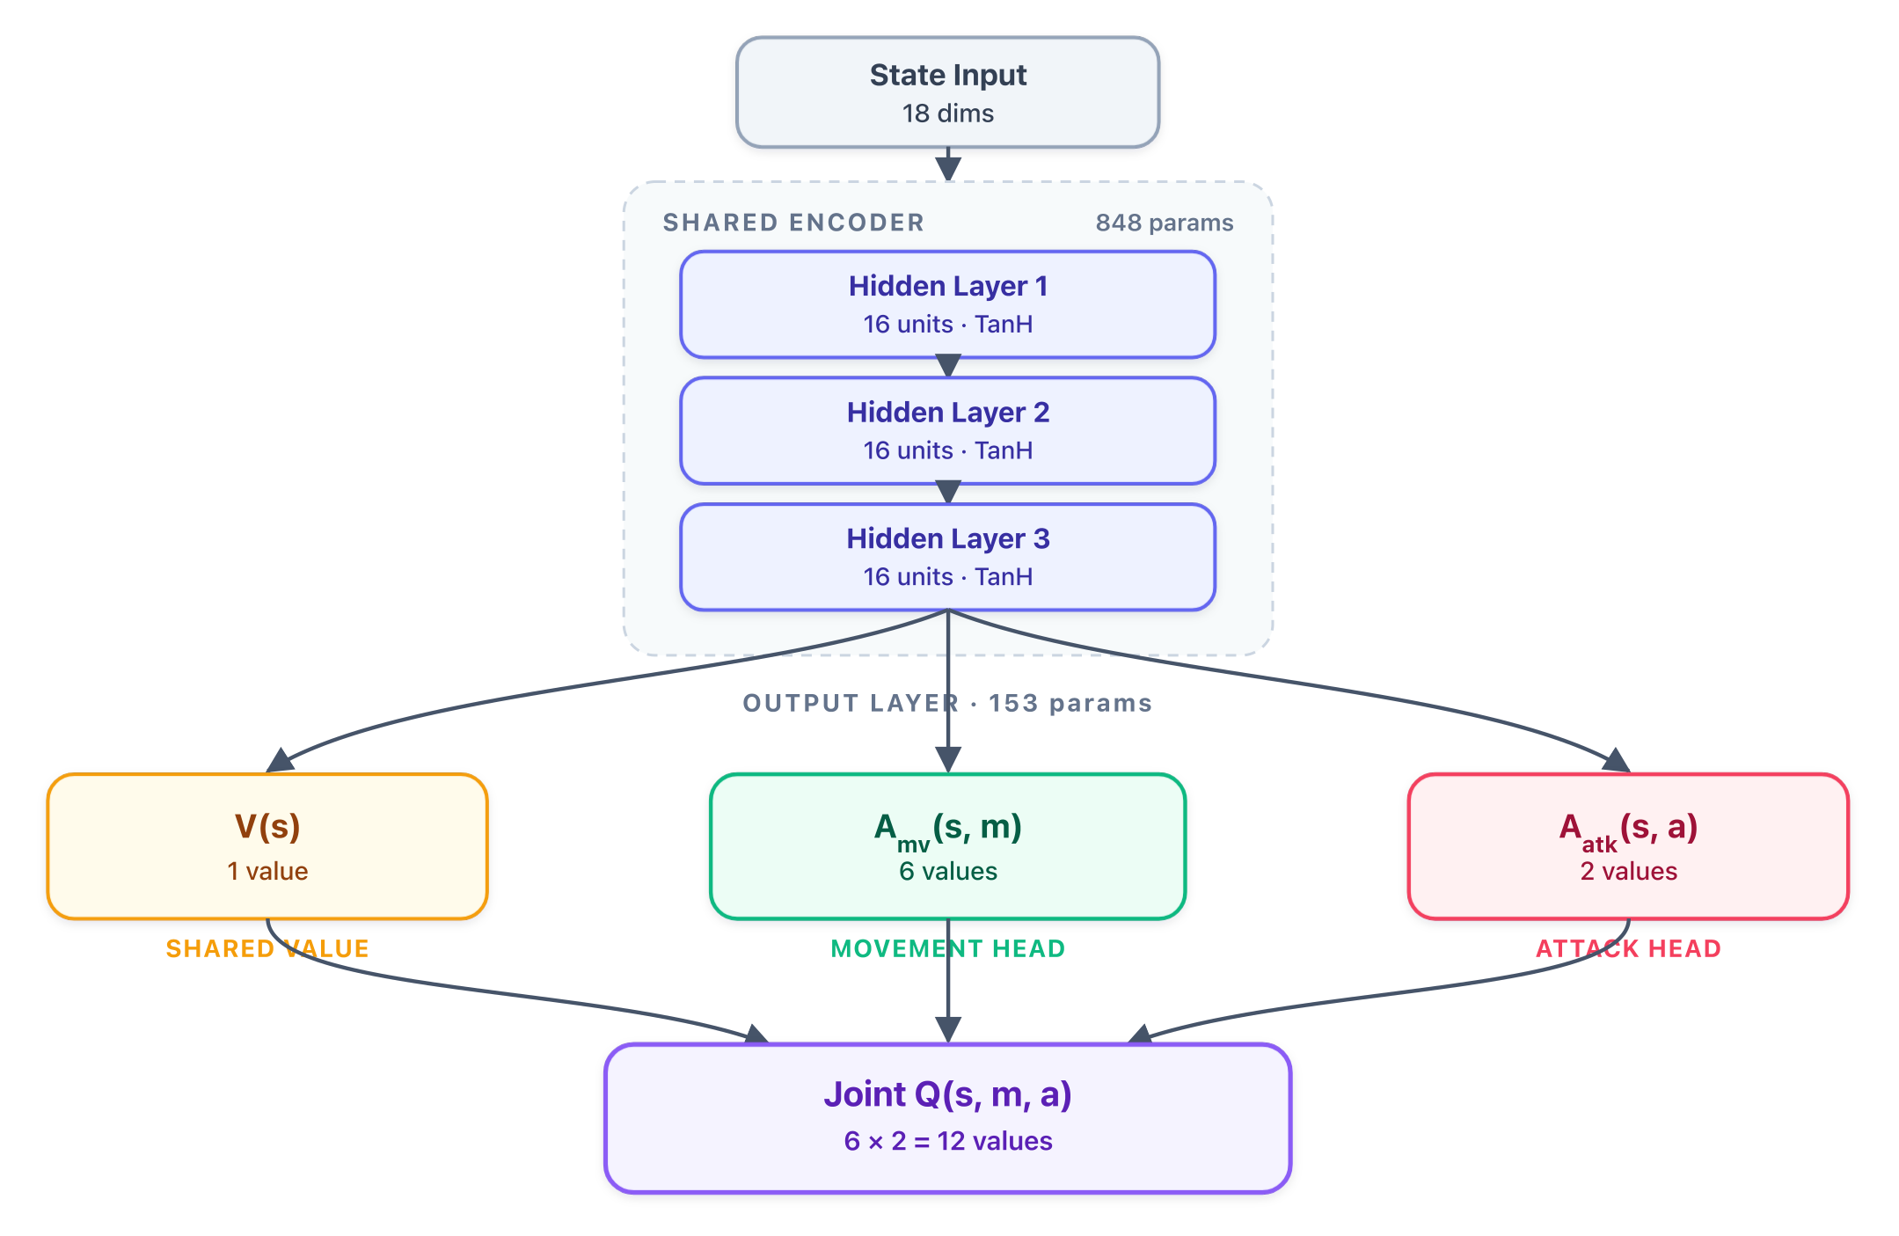
Supplementary Figure S1 | The factored dual-head model. A shared 18–16–16–16 encoder feeds a state value and separate movement (6) and attack (2) advantage branches, recombined additively into twelve joint-action values. The flat-joint model outputs the twelve values directly over the same joint actions.
---
Representative evaluation frames
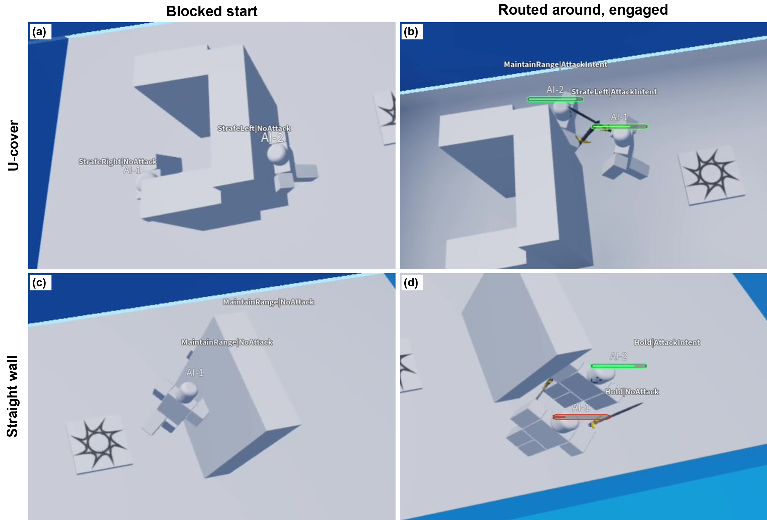
Supplementary Figure S2 | Representative evaluation frames for the U-shaped cover (top row) and the straight-wall occluder (bottom row). Left: blocked starts with LOS occluded. Right: recovered engagements after routing around cover. Colored bars show health.
---
Recovery and failure-class breakdown
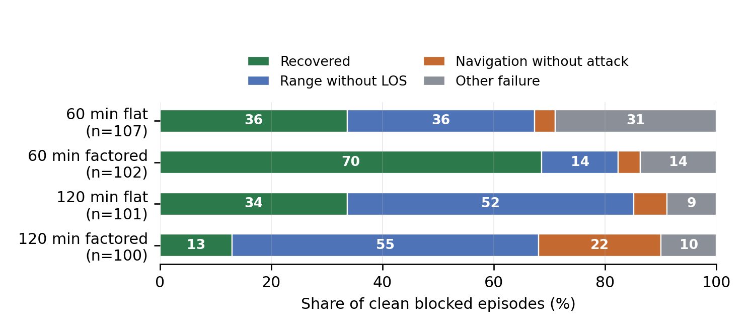
Supplementary Figure S3 | Recovery and failure-class breakdown for the same clean blocked-start pair episodes as Table 4. Range-without-LOS means sword-range distance while still occluded. Navigation-without-attack means clear LOS and range with no swing of the NPC's own logged. Other includes no-recovery, stall, near-cover, and swing-without-hit cases. Occluders are pooled because the clean pair-episode ledger lacks reliable per-episode occluder labels. The recovered counts drawn here are the originally reported any-side figures for the four cells (36, 70, 34, 13). The manuscript's primary NPC-1 figures for the same cells are 36, 51, 34 and 9. The two idioms count different events by construction and do not conflict.

