Table S1. Out-of-sample per-lap predictions of finishing points (predicted and actual) for all four models across the five expanding-window folds (selection Windows 1 - 4, testing the 2021 - 2024 seasons, and the held-out 2025 test season; 2,177 driver-races), provided as a CSV file. Predictions begin at each driver's fourth lap with a complete lag window. In 288 of 2,177 driver-races (13.2%) the first scored lap is later, because the opening laps are missing or incomplete. In the held-out 2025 season this affects 75 driver-races (every driver at the Saudi Arabian (first scored lap 6), Australian (7), Azerbaijan (7), and Belgian (7) Grands Prix, and one driver at the British Grand Prix (lap 5)).
Table S2a. The top 25 of the 236 features by mean absolute SHAP value (points) for XGBoost on the held-out 2025 season, with each feature's permutation R² drop and the model's built-in gain importance. The full 236-feature list is provided as a CSV file.
Rank | Feature | Category | Mean |SHAP| (points) | Permutation R² drop | Built-in gain
1 | Position | Position | 2.2254 | 0.3062 | 0.0799
2 | Position_lag1 | Position | 0.9955 | 0.0586 | 0.1133
3 | Position_lag3 | Position | 0.9403 | 0.0610 | 0.0658
4 | Position_lag2 | Position | 0.7357 | 0.0316 | 0.1144
5 | GridPosition_lastyr | Position | 0.2281 | 0.0017 | 0.0062
6 | Stint | Timing & tire | 0.1495 | 0.0029 | 0.0039
7 | TyreLife | Timing & tire | 0.1431 | 0.0021 | 0.0026
8 | FinalPosition_lastyr | Position | 0.1336 | -0.0017 | 0.0036
9 | Driver_enc | Identity | 0.1299 | 0.0005 | 0.0047
10 | points_no_fl_lastyr | Position | 0.1203 | -0.0018 | 0.0071
11 | points_with_fl_lastyr | Position | 0.0934 | -0.0022 | 0.0043
12 | TyreLife_lag1 | Timing & tire | 0.0888 | 0.0008 | 0.0027
13 | Stint_lag1 | Timing & tire | 0.0847 | 0.0010 | 0.0041
14 | Position_lag2_lastyr | Position | 0.0813 | -0.0001 | 0.0331
15 | Position_lastyr | Position | 0.0743 | 0.0000 | 0.0245
16 | Position_lag1_lastyr | Position | 0.0734 | -0.0002 | 0.0285
17 | Position_lag3_lastyr | Position | 0.0647 | -0.0002 | 0.0302
18 | DRS | Telemetry | 0.0627 | -0.0001 | 0.0016
19 | TyreLife_lag2 | Timing & tire | 0.0398 | 0.0002 | 0.0027
20 | LapNumber | Always kept | 0.0398 | 0.0004 | 0.0016
21 | Stint_lag2 | Timing & tire | 0.0344 | 0.0004 | 0.0042
22 | DRS_lag1 | Telemetry | 0.0222 | -0.0001 | 0.0016
23 | MeanCornerRadius_lastyr | Circuit | 0.0192 | 0.0002 | 0.0036
24 | LRCornerBalance | Circuit | 0.0136 | -0.0001 | 0.0044
25 | Stint_lag3 | Timing & tire | 0.0136 | 0.0001 | 0.0035
Table S2b. Share of the total mean absolute SHAP attribution and of the total permutation R² drop by feature category, for XGBoost on the held-out 2025 season. Negative permutation drops are set to zero before the shares are computed.
Category | Features | Share of total |SHAP| (%) | Share of total permutation R² drop (%)
Position | 12 | 79.57 | 97.59
Timing & tire | 75 | 10.96 | 1.84
Telemetry | 80 | 3.99 | 0.13
Weather | 41 | 0.90 | 0.10
Circuit | 21 | 1.90 | 0.09
Identity | 5 | 1.95 | 0.15
Always kept | 2 | 0.72 | 0.09
Total | 236 | 100.00 | 100.00
Table S3. R² and MAE for the full XGBoost model and each of the six leave one category out ablation runs, each independently retuned over the same grid, on selection Windows 1 - 4 (testing the 2021 - 2024 seasons) and the held-out 2025 test season.
Metric | Feature set | W1 (2021)  n = 22,070 | W2 (2022)  n = 21,752 | W3 (2023)  n = 22,682 | W4 (2024)  n = 24,956 | W5 (2025, test)  n = 24,946
R² | All features | 0.7398 | 0.7643 | 0.8000 | 0.8000 | 0.7933
R² | All - position | 0.4548 | 0.1768 | 0.4071 | 0.3481 | 0.4176
R² | All - timing & tire | 0.7283 | 0.7582 | 0.7882 | 0.7928 | 0.7865
R² | All - telemetry | 0.7385 | 0.7647 | 0.7991 | 0.7996 | 0.7929
R² | All - weather | 0.7557 | 0.7631 | 0.7984 | 0.7996 | 0.7923
R² | All - circuit | 0.7481 | 0.7579 | 0.7974 | 0.7987 | 0.7934
R² | All - identity | 0.7390 | 0.7684 | 0.7981 | 0.8004 | 0.7920
MAE | All features | 2.3348 | 2.2042 | 2.0442 | 1.8811 | 1.9840
MAE | All - position | 4.0254 | 5.1885 | 4.5131 | 4.4166 | 4.1828
MAE | All - timing & tire | 2.4495 | 2.2883 | 2.1553 | 2.0282 | 2.1078
MAE | All - telemetry | 2.3258 | 2.1933 | 2.0416 | 1.8837 | 1.9790
MAE | All - weather | 2.2208 | 2.2033 | 2.0555 | 1.8882 | 1.9985
MAE | All - circuit | 2.2656 | 2.2080 | 2.0592 | 1.8908 | 1.9954
MAE | All - identity | 2.3112 | 2.1719 | 2.0488 | 1.8669 | 1.9799
Table S4a. R² and MAE (points) on the held-out 2025 season for the four baselines described in the Results (the points table applied to the grid position, the current-lap position, and the previous-lap position, and an XGBoost model given only the current position and its three race lags) and the four full models, with 95% percentile intervals from 500 bootstrap draws resampling driver-races.
System | R² | R² 95% CI | MAE (points) | MAE 95% CI
Grid-position lookup | 0.6627 | [0.5586, 0.7525] | 2.3324 | [1.9643, 2.6616]
Current-position lookup | 0.7584 | [0.6891, 0.8154] | 1.7445 | [1.5107, 1.9620]
Previous-lap lookup | 0.7545 | [0.6847, 0.8121] | 1.7742 | [1.5375, 1.9929]
Position-only XGBoost | 0.7893 | [0.7344, 0.8349] | 2.0339 | [1.8151, 2.2302]
XGBoost | 0.7933 | [0.7345, 0.8429] | 1.9840 | [1.7592, 2.1967]
Random Forest | 0.7856 | [0.7269, 0.8338] | 2.0615 | [1.8481, 2.2610]
LightGBM | 0.7901 | [0.7364, 0.8365] | 2.1069 | [1.8888, 2.3053]
Extra Trees | 0.7805 | [0.7190, 0.8301] | 2.1310 | [1.9035, 2.3369]
Table S4b. XGBoost's improvement over each baseline on the held-out 2025 season, in R² (positive = XGBoost higher) and in MAE (positive = XGBoost lower), with 95% percentile intervals from 500 paired bootstrap draws in which the baseline and XGBoost are scored on the same resampled driver-races. A negative MAE reduction means the baseline had the lower MAE.
Baseline | XGBoost R² gain | 95% CI | XGBoost MAE reduction | 95% CI
Grid-position lookup | +0.1306 | [+0.0725, +0.1990] | +0.3484 | [+0.0893, +0.5915]
Current-position lookup | +0.0349 | [+0.0188, +0.0536] | -0.2395 | [-0.3369, -0.1461]
Previous-lap lookup | +0.0388 | [+0.0225, +0.0581] | -0.2098 | [-0.3064, -0.1136]
Position-only XGBoost | +0.0040 | [-0.0100, +0.0164] | +0.0498 | [-0.0173, +0.1152]
Table S5a. Pairwise differences in MAE (points) between the four models on the held-out 2025 season, scored per lap and with every driver's race counting equally, with 95% percentile intervals from 500 paired bootstrap draws resampled at the driver-race, race, and driver levels. The difference is the first model minus the second, so a negative difference means the first model had a lower MAE, and pairs are ordered as in Table 5.
Pair | Scoring | Difference | 95% CI, driver-race | 95% CI, race | 95% CI, driver
XGBoost - Random Forest | Per lap | -0.0775 | [-0.1057, -0.0455] | [-0.1126, -0.0396] | [-0.1014, -0.0559]
XGBoost - Random Forest | Equal weight | -0.0693 | [-0.0976, -0.0375] | [-0.1017, -0.0331] | [-0.0955, -0.0457]
XGBoost - LightGBM | Per lap | -0.1229 | [-0.1509, -0.0980] | [-0.1485, -0.0981] | [-0.1548, -0.0927]
XGBoost - LightGBM | Equal weight | -0.1224 | [-0.1486, -0.0979] | [-0.1486, -0.0964] | [-0.1533, -0.0925]
XGBoost - Extra Trees | Per lap | -0.1470 | [-0.1878, -0.1072] | [-0.1808, -0.1136] | [-0.2076, -0.0969]
XGBoost - Extra Trees | Equal weight | -0.1410 | [-0.1812, -0.1018] | [-0.1719, -0.1123] | [-0.2007, -0.0871]
Random Forest - LightGBM | Per lap | -0.0454 | [-0.0788, -0.0170] | [-0.0807, -0.0149] | [-0.0826, -0.0129]
Random Forest - LightGBM | Equal weight | -0.0531 | [-0.0868, -0.0241] | [-0.0865, -0.0210] | [-0.0879, -0.0176]
Random Forest - Extra Trees | Per lap | -0.0696 | [-0.1051, -0.0356] | [-0.0979, -0.0415] | [-0.1211, -0.0271]
Random Forest - Extra Trees | Equal weight | -0.0716 | [-0.1080, -0.0369] | [-0.1008, -0.0410] | [-0.1218, -0.0285]
LightGBM - Extra Trees | Per lap | -0.0242 | [-0.0554, +0.0072] | [-0.0582, +0.0107] | [-0.0703, +0.0148]
LightGBM - Extra Trees | Equal weight | -0.0186 | [-0.0496, +0.0133] | [-0.0516, +0.0145] | [-0.0668, +0.0213]
Table S5b. Pairwise differences in R² between the four models on the held-out 2025 season, scored per lap and with every driver's race counting equally, with 95% percentile intervals from 500 paired bootstrap draws resampled at the driver-race, race, and driver levels. The difference is the first model minus the second, and pairs are ordered as in Table 5.
Pair | Scoring | Difference | 95% CI, driver-race | 95% CI, race | 95% CI, driver
XGBoost - Random Forest | Per lap | +0.0077 | [+0.0003, +0.0146] | [-0.0006, +0.0156] | [+0.0042, +0.0140]
XGBoost - Random Forest | Equal weight | +0.0079 | [+0.0005, +0.0147] | [-0.0002, +0.0158] | [+0.0054, +0.0141]
XGBoost - LightGBM | Per lap | +0.0031 | [-0.0031, +0.0091] | [-0.0036, +0.0088] | [-0.0013, +0.0077]
XGBoost - LightGBM | Equal weight | +0.0030 | [-0.0032, +0.0087] | [-0.0036, +0.0088] | [-0.0009, +0.0073]
XGBoost - Extra Trees | Per lap | +0.0128 | [+0.0058, +0.0194] | [+0.0060, +0.0199] | [+0.0078, +0.0176]
XGBoost - Extra Trees | Equal weight | +0.0115 | [+0.0042, +0.0182] | [+0.0051, +0.0179] | [+0.0039, +0.0166]
Random Forest - LightGBM | Per lap | -0.0046 | [-0.0109, +0.0011] | [-0.0089, +0.0005] | [-0.0102, -0.0012]
Random Forest - LightGBM | Equal weight | -0.0049 | [-0.0119, +0.0014] | [-0.0103, +0.0006] | [-0.0118, -0.0006]
Random Forest - Extra Trees | Per lap | +0.0051 | [-0.0013, +0.0110] | [-0.0004, +0.0119] | [-0.0018, +0.0092]
Random Forest - Extra Trees | Equal weight | +0.0036 | [-0.0035, +0.0104] | [-0.0029, +0.0110] | [-0.0071, +0.0090]
LightGBM - Extra Trees | Per lap | +0.0097 | [+0.0034, +0.0168] | [+0.0034, +0.0174] | [+0.0040, +0.0148]
LightGBM - Extra Trees | Equal weight | +0.0085 | [+0.0019, +0.0159] | [+0.0027, +0.0164] | [+0.0014, +0.0143]
Table S6. Clustered Diebold-Mariano tests on absolute error for each model pair on the held-out 2025 season (462 driver-race clusters per pair). Columns give the mean difference in absolute error, the clustered standard error, the test statistic, raw and Holm-adjusted p-values, and the first model's share of driver-races won. The model with the lower 2025 MAE is listed first, as in Table 5.
Pair | Driver-races | Mean difference in absolute error | Clustered SE | DM statistic | Raw p | Holm-adjusted p | First model wins (%)
XGBoost / Random Forest | 462 | -0.0775 | 0.0160 | -4.84 | 1.82 × 10⁻⁶ | 7.27 × 10⁻⁶ | 65.6
XGBoost / LightGBM | 462 | -0.1229 | 0.0144 | -8.52 | 2.22 × 10⁻¹⁶ | 1.33 × 10⁻¹⁵ | 73.8
XGBoost / Extra Trees | 462 | -0.1470 | 0.0194 | -7.57 | 2.12 × 10⁻¹³ | 1.06 × 10⁻¹² | 68.6
Random Forest / LightGBM | 462 | -0.0454 | 0.0156 | -2.90 | 0.0039 | 0.0077 | 59.7
Random Forest / Extra Trees | 462 | -0.0696 | 0.0174 | -4.00 | 7.41 × 10⁻⁵ | 2.22 × 10⁻⁴ | 53.5
LightGBM / Extra Trees | 462 | -0.0242 | 0.0149 | -1.62 | 0.1061 | 0.1061 | 47.0
Table S7. Per-lap R² and MAE (points) of the lag-free XGBoost model on the held-out 2025 season for laps 1 through 12, with the number of driver-races per lap and, from lap 4 onward, the main lagged model's per-lap MAE for comparison. The Driver-races column counts the lag-free model’s coverage. At laps 4 to 6 the main model covers fewer driver-races (387, 387, and 402), and from lap 7 onward the two models cover the same driver-races.
Lap | Driver-races | Lag-free R² | Lag-free MAE | Main model MAE
1 | 440 | 0.693 | 2.615 | -
2 | 389 | 0.706 | 2.544 | -
3 | 388 | 0.716 | 2.514 | -
4 | 406 | 0.722 | 2.488 | 2.471
5 | 461 | 0.725 | 2.497 | 2.458
6 | 458 | 0.733 | 2.485 | 2.412
7 | 457 | 0.734 | 2.464 | 2.429
8 | 456 | 0.739 | 2.438 | 2.395
9 | 455 | 0.742 | 2.424 | 2.373
10 | 456 | 0.737 | 2.443 | 2.368
11 | 456 | 0.731 | 2.470 | 2.374
12 | 456 | 0.730 | 2.472 | 2.363
Table S8. The two era-specific XGBoost models (pre-change, trained on 2019 - 2020 and tested on 2021, and post-change, trained on 2023 - 2024 and tested on 2025) with their selected hyperparameters, selection and test R² and MAE (95% driver-race cluster bootstrap confidence intervals on test), and the full model's difference to the post-change model on the shared 2025 test season. Each era model was tuned on a single selection window (validating on 2020 and 2024 respectively).
 | Pre-change model | Post-change model
Training seasons | 2019 - 2020 | 2023 - 2024
Selection (train → validate) | 2019 → 2020 | 2023 → 2024
Test season | 2021 | 2025
learning_rate | 0.015 | 0.005
n_estimators | 800 | 800
max_depth | 4 | 4
colsample_bynode | 0.4 | 0.4
subsample | 0.3 | 0.3
Selection R² | 0.6603 | 0.7755
Selection MAE | 2.6908 | 2.0990
Test R² [95% CI] | 0.7340 [0.6809, 0.7811] | 0.7839 [0.7313, 0.8247]
Test MAE [95% CI] | 2.3597 [2.1222, 2.6159] | 2.1110 [1.9289, 2.3137]
Full model - post-change model on 2025, MAE [95% CI] | - | -0.1276 [-0.1789, -0.0718]
Full model - post-change model on 2025, R² [95% CI] | - | +0.0095 [-0.0032, +0.0201]
Table S9. Race-level coherence on the held-out 2025 season. For each model and race checkpoint (25%, 50%, 75%, and 100% of race laps), the table gives the number of races, the sum of predicted points across the field divided by the sum of actual points averaged over races, and the share of races with two drivers predicted at 20 or more points (zero throughout). The 0.99 to 1.05 range quoted in the text is XGBoost's.
Model | Checkpoint (% of race) | Races | Sum predicted ÷ sum actual points | Races with two drivers predicted ≥ 20 points (%)
XGBoost | 25 | 24 | 0.9979 | 0.0
XGBoost | 50 | 24 | 1.0184 | 0.0
XGBoost | 75 | 24 | 1.0428 | 0.0
XGBoost | 100 | 24 | 1.0435 | 0.0
Random Forest | 25 | 24 | 1.0182 | 0.0
Random Forest | 50 | 24 | 1.0346 | 0.0
Random Forest | 75 | 24 | 1.0512 | 0.0
Random Forest | 100 | 24 | 1.0645 | 0.0
LightGBM | 25 | 24 | 0.9987 | 0.0
LightGBM | 50 | 24 | 1.0238 | 0.0
LightGBM | 75 | 24 | 1.0391 | 0.0
LightGBM | 100 | 24 | 1.0510 | 0.0
Extra Trees | 25 | 24 | 1.0098 | 0.0
Extra Trees | 50 | 24 | 1.0173 | 0.0
Extra Trees | 75 | 24 | 1.0318 | 0.0
Extra Trees | 100 | 24 | 1.0446 | 0.0
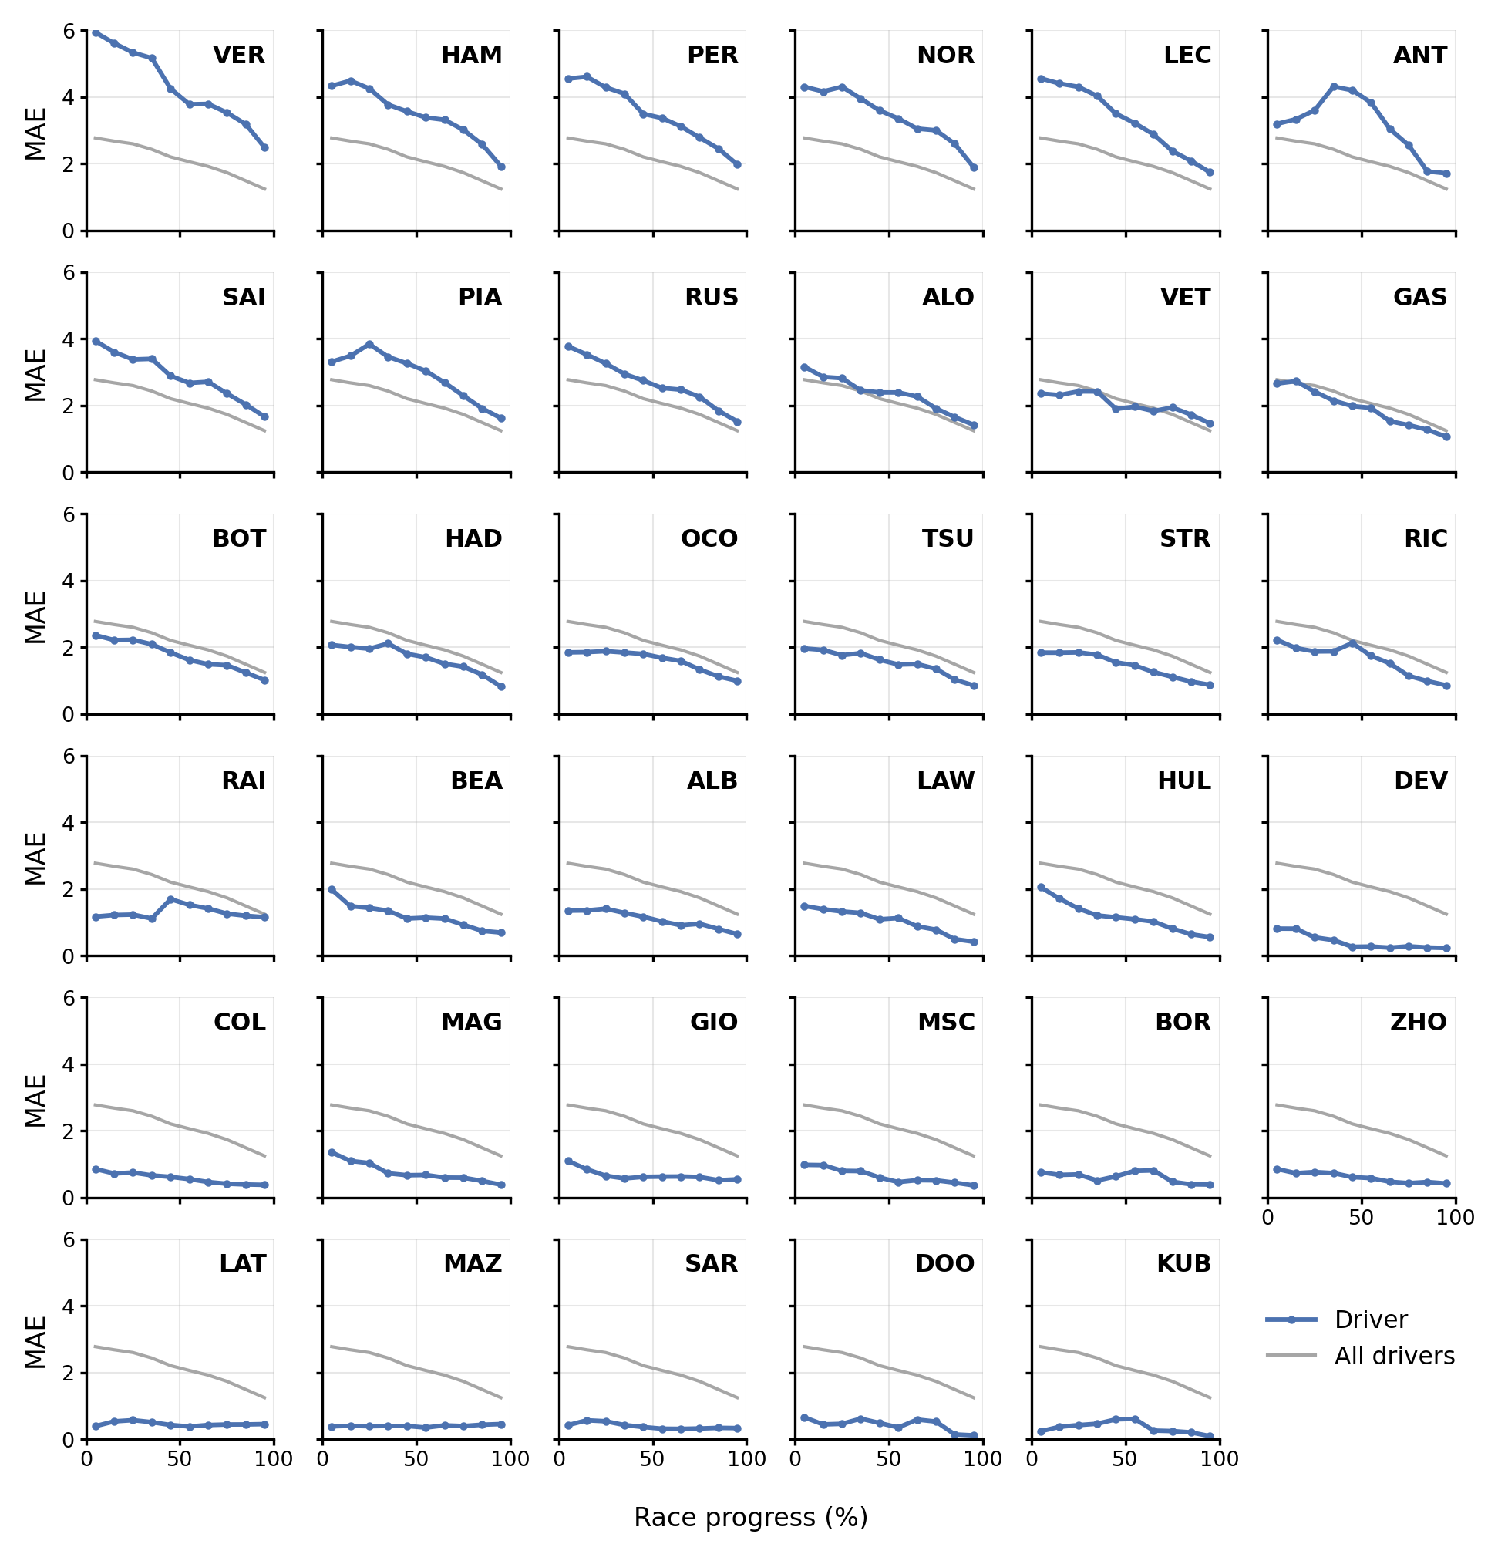
Figure S1. XGBoost's MAE (points) by race progress (%), one panel per driver, pooled over the five cross-validation windows in which each driver appears (the 2021 - 2024 selection seasons and the held-out 2025 season). Panels are ordered worst to best as in Figure 2, and the grey line is all drivers pooled.
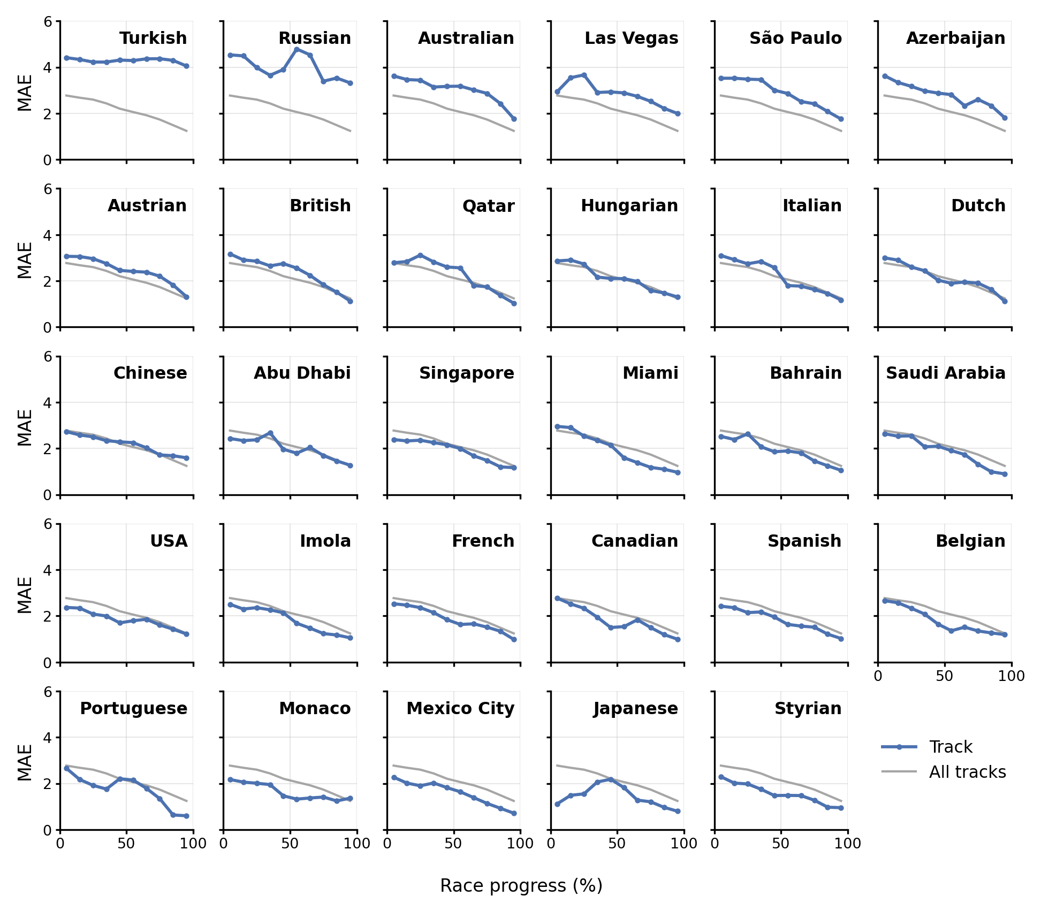
Figure S2. XGBoost's MAE (points) by race progress (%), one panel per track, pooled over the five cross-validation windows in which each track appears (the 2021 - 2024 selection seasons and the held-out 2025 season). Panels are ordered worst to best as in Figure 2, and the grey line is all tracks pooled.
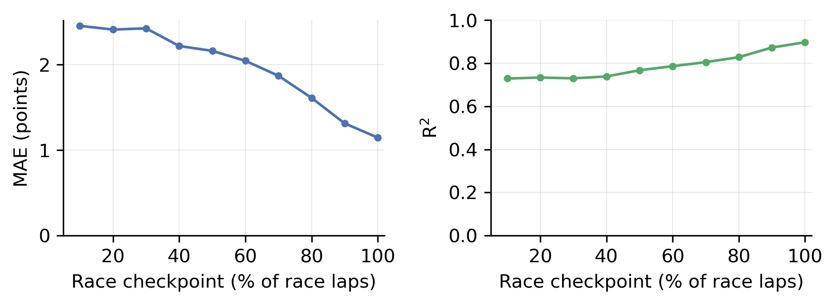
Figure S3. XGBoost's MAE (points, left) and R² (right) on the held-out 2025 season at fixed race checkpoints (10% through 100% of race laps), with a retired driver's last available prediction carried forward through the remaining checkpoints. At the 10% checkpoint, 388 of the 462 driver-races have a prediction, and all 462 are scored from 20% onward.
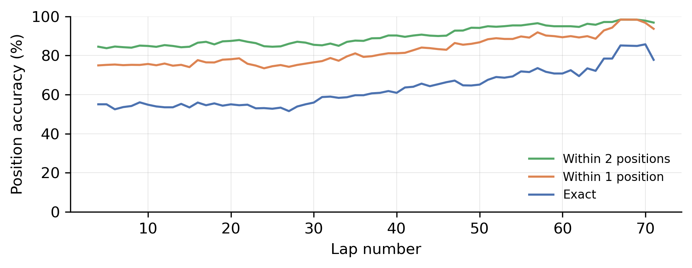
Figure S4. Capped position accuracy by lap for XGBoost on the held-out 2025 season. The lines show the share of driver-laps whose predicted finishing position is exactly correct, within one position, and within two positions, with predicted and actual positions capped at 11th so all non-points finishers form a single bucket. Laps with fewer than 40 driver-races are not shown.
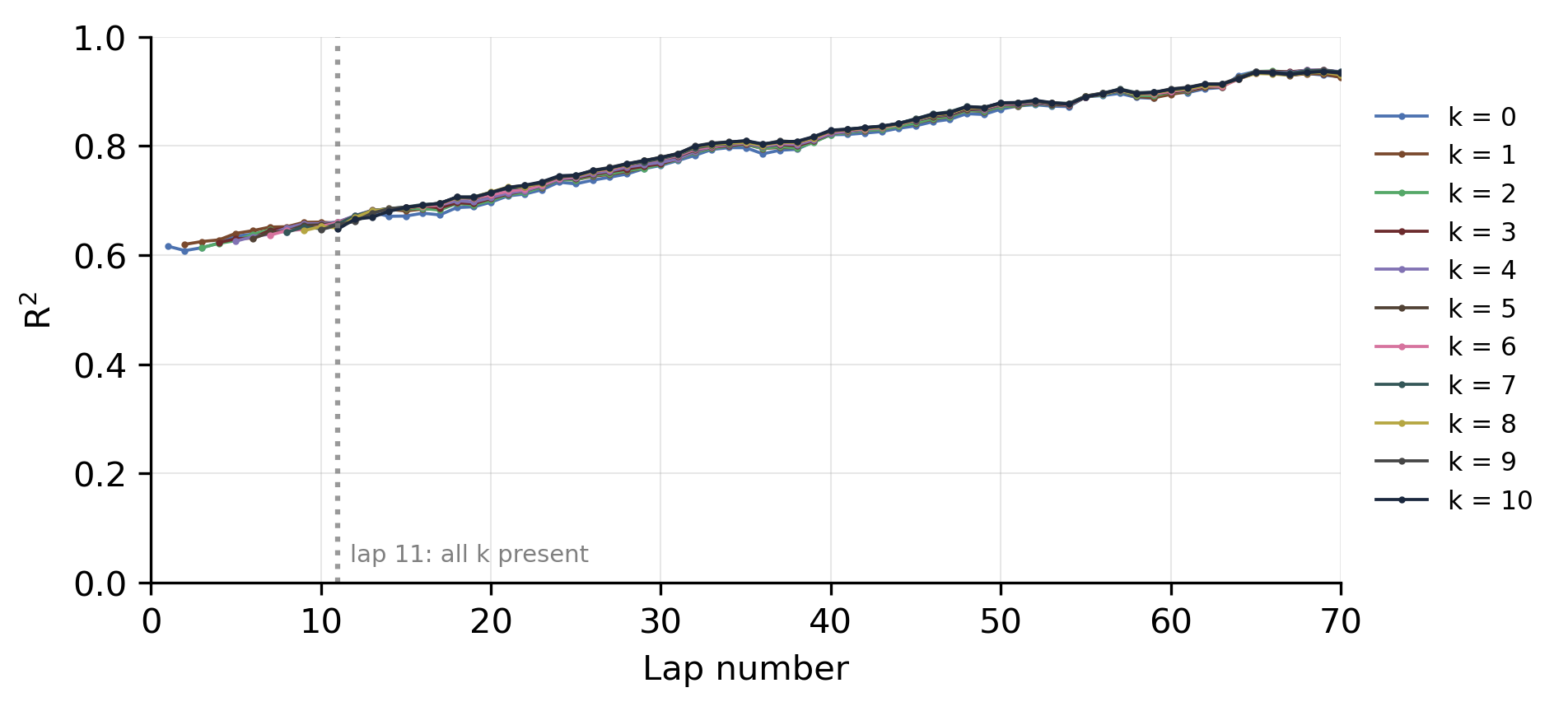
Figure S5. Per-lap R² at each within-race lag depth k from 0 to 10, each depth separately tuned and pooled across the four selection windows, leaving the held-out 2025 season out of the lag choice, shown for XGBoost as the reference model. This is the R² companion to Figure 3 (MAE), from the same run. Line k begins at lap k+1, and the dotted line at lap 11 marks the first laps on which all depths are scored.
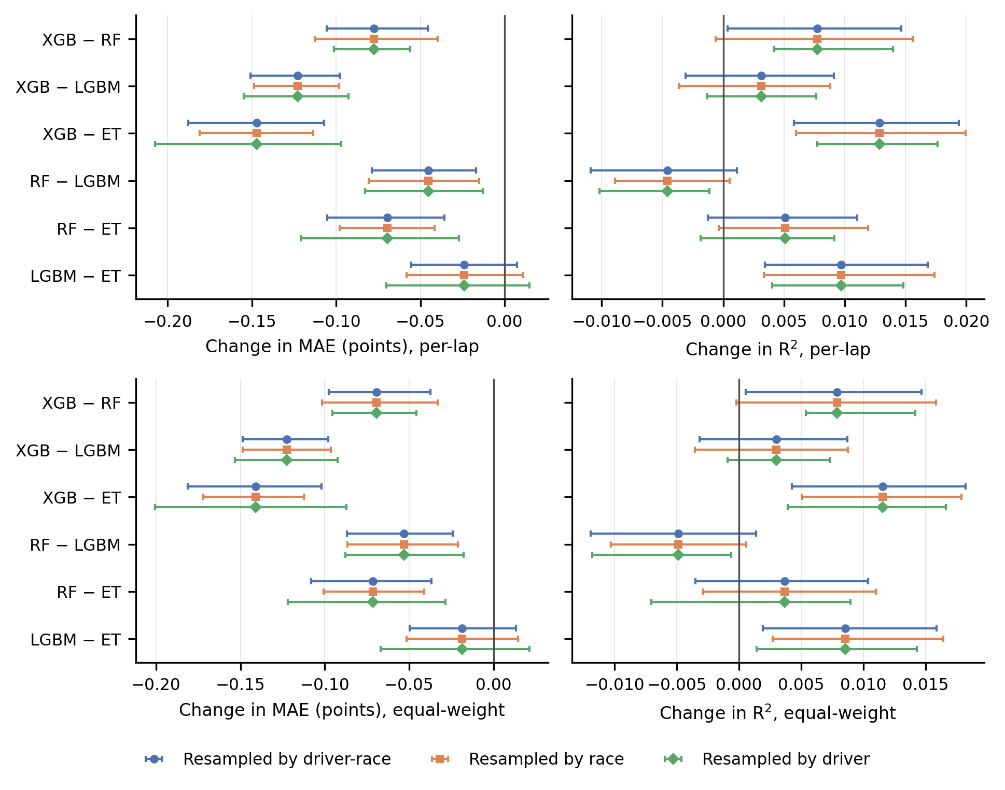
Figure S6. Differences between the four models on the held-out 2025 season (XGB = XGBoost, RF = Random Forest, LGBM = LightGBM, ET = Extra Trees) in MAE (left) and R² (right), scored per lap (top) and with every driver's race counting equally (bottom), with 95% percentile intervals from 500 paired bootstrap draws resampled at the driver-race, race, and driver levels. The difference is the first model minus the second, so a negative MAE difference means the first model had a lower MAE, and pairs are ordered as in Table 5.
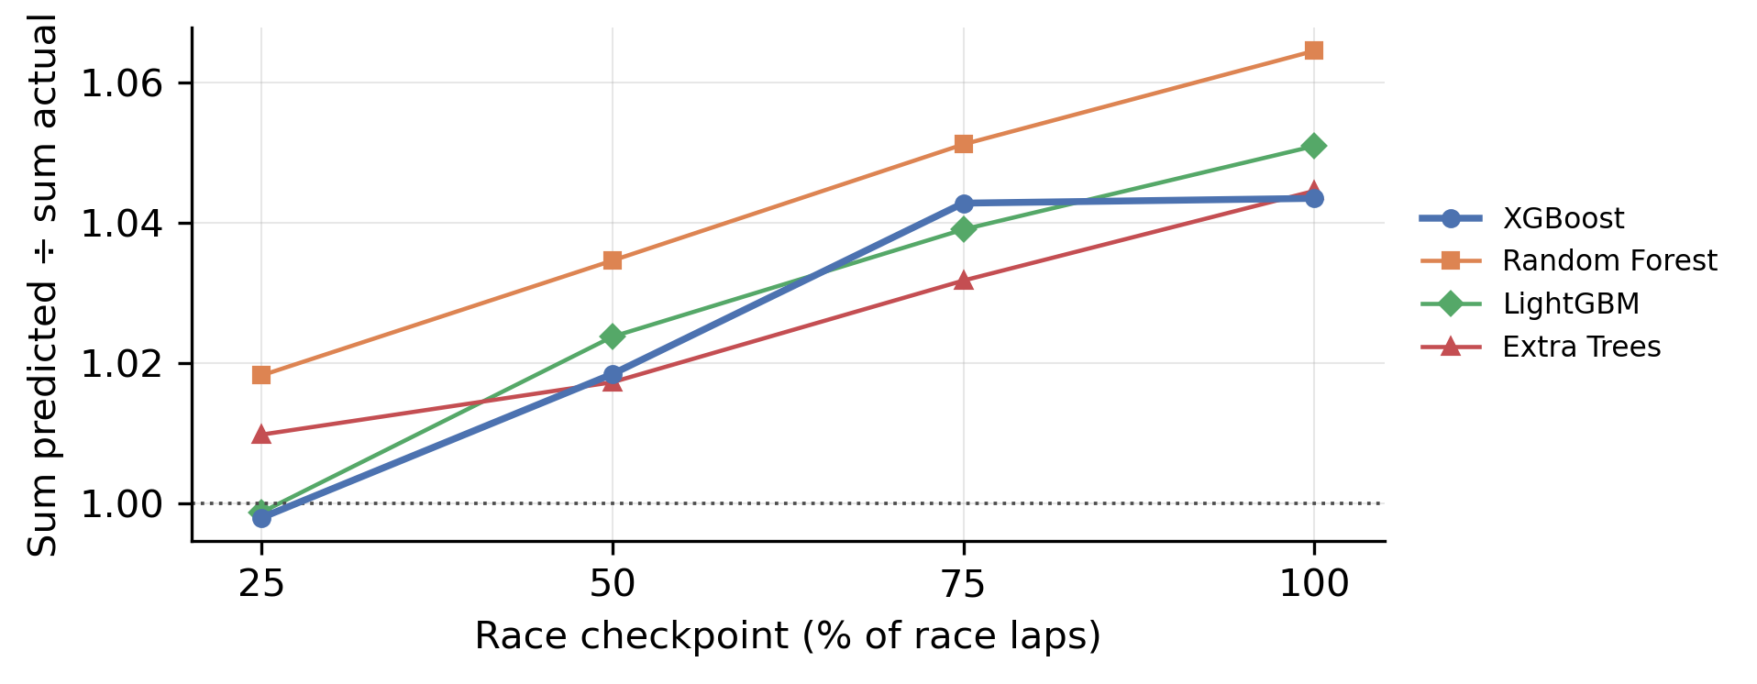
Figure S7. Sum of predicted points across the field divided by the sum of actual points, averaged over the races of the held-out 2025 season, at the 25%, 50%, 75%, and 100% race checkpoints, one line per model. The 0.99 to 1.05 range quoted in the text is XGBoost's.
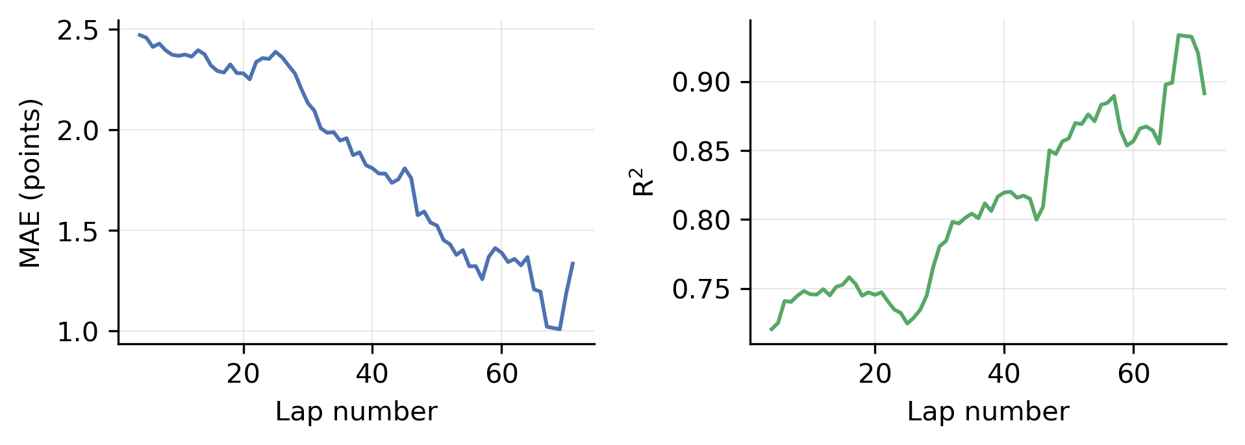
Figure S8. XGBoost's per-lap MAE (points, left) and R² (right) on the held-out 2025 season. Laps with fewer than 40 driver-races are not shown.

