Supplementary Material
Longitudinal Patterns of Sustained and Peak Cardiovascular Responses in a Rider–Horse Dyad During Hunter Training
Supplementary Table S1 Environmental conditions during the eleven training sessions
Training  Session | Training Environment | Daily Maximum Temperature (°F) | Daily Minimum Temperature (°F) | Average Wind Speed (mph) | Daily Precipitation (in.)
2025-12-16_A | Outdoor | 53 | 26 | 4.92 | 0
2025-12-18_A | Outdoor | 61 | 35 | 5.37 | 0.06
2025-12-19_A | Outdoor | 63 | 40 | 10.51 | 0.81
2025-12-23_A | Outdoor | 65 | 40 | 8.95 | 0
2025-12-29_A | Outdoor | 63 | 34 | 12.3 | 0.05
2025-12-30_A | Outdoor | 40 | 27 | 6.49 | 0
2026-01-02_A | Outdoor | 59 | 28 | 2.24 | 0
2026-01-06_A | Outdoor | 66 | 37 | 6.04 | 0
2026-01-13_A | Outdoor | 59 | 28 | 6.93 | 0
2026-01-16_A | Outdoor | 46 | 21 | 7.83 | 0
2026-01-19_A | Outdoor | 47 | 23 | 4.47 | 0
Note. The horse-management routine described in the Methods applied to all eleven sessions, with no session-specific deviations in turnout, feeding, prior exercise, housing, or handling.

Supplementary Table S2. Characteristics of annotated jump events and event-window overlap across training sessions.
Session | Order |  | Jump events | Median inter-jump interval (s) | Prior-jump baseline overlap | Subsequent-jump response overlap | Events with any overlap | Overlap (%) | Non-overlapping events
2025-12-16_A | 1 |  | 11 | 20.0 | 7.0 | 5.0 | 9.0 | 81.8 | 2
2025-12-18_A | 2 |  | 7 | 9.5 | 4.0 | 4.0 | 7.0 | 100.0 | 0
2025-12-23_A | 4 |  | 12 | 18.0 | 7.0 | 6.0 | 10.0 | 83.3 | 2
2025-12-29_A | 5 |  | 6 | 7.0 | 4.0 | 4.0 | 6.0 | 100.0 | 0
2025-12-30_A | 6 |  | 16 | 25.0 | 8.0 | 7.0 | 13.0 | 81.3 | 3
2026-01-02_A |  | 7 | 11 | 18.0 | 6.0 | 5.0 | 9.0 | 81.8 | 2
2026-01-13_A |  | 9 | 11 | 26.0 | 7.0 | 4.0 | 9.0 | 81.8 | 2
2026-01-16_A |  | 10 | 13 | 20.0 | 8.0 | 7.0 | 11.0 | 84.6 | 2
Note. Values summarize the annotated jump events included in the primary Δpeak analysis. Median inter-jump interval was calculated within each training session. Overlap refers to events whose predefined 30-s baseline or 20-s response window overlapped with another annotated jump event. Non-overlapping ("clean") events were used only for sensitivity analyses.

Supplementary Table S3. Summary of RR interval preprocessing and quality-control outcomes for each training session
Session | Raw RR | Offline removed | Range removed (300–3000 ms) | Local-median removed | Hampel removed | Total removed | Removal (%) | Final NN | Retention (%) | Residual QA flags | Residual QA (%)
S1 | 2560 | 61 | 194 | 330 | 75 | 660 | 25.8 | 1900 | 74.2 | 3 | 0.16
S2 | 2346 | 40 | 142 | 420 | 154 | 756 | 32.2 | 1590 | 67.8 | 2 | 0.13
S3 | 3234 | 31 | 123 | 465 | 199 | 818 | 25.3 | 2416 | 74.7 | 5 | 0.21
S4 | 2522 | 30 | 68 | 254 | 133 | 485 | 19.2 | 2037 | 80.8 | 2 | 0.10
S5 | 2509 | 23 | 139 | 388 | 126 | 676 | 26.9 | 1833 | 73.1 | 6 | 0.33
S6 | 3509 | 51 | 342 | 536 | 188 | 1117 | 31.8 | 2392 | 68.2 | 7 | 0.29
S7 | 2967 | 38 | 112 | 339 | 83 | 572 | 19.3 | 2395 | 80.7 | 2 | 0.08
S8 | 2359 | 16 | 88 | 265 | 117 | 486 | 20.6 | 1873 | 79.4 | 1 | 0.05
S9 | 2519 | 35 | 212 | 260 | 57 | 564 | 22.4 | 1955 | 77.6 | 0 | 0.00
S10 | 2266 | 25 | 169 | 452 | 92 | 738 | 32.6 | 1528 | 67.4 | 2 | 0.13
S11 | 2924 | 43 | 221 | 475 | 102 | 841 | 28.8 | 2083 | 71.2 | 12 | 0.58
Note. RR intervals were sequentially processed using four quality-control steps: (1) removal of device-identified offline recordings; (2) exclusion of intervals outside the broad physiological range of 300–3000 ms; (3) removal of locally inconsistent intervals using a centered 11-beat local-median rule (RR > 1.75× or < 0.50× the local median); and (4) removal of residual isolated artifacts using an 11-beat Hampel filter with a threshold equal to the greater of 3 × 1.4826 × the median absolute deviation (MAD) or 150 ms. Total removed intervals represent cumulative exclusions across all steps, and final NN intervals were retained for HRV calculation. Residual QA flags denote retained NN intervals flagged by the final automated quality-assurance screen but not meeting the predefined exclusion criteria. The 300–3000 ms range served only as a broad gross-error screen; intervals within this range could still be excluded by the local-median or Hampel criteria. Representative preprocessing examples are provided in Supplementary Figure S1.

Supplementary Table S4. Summary of whole-session and standardized 5-minute stable-walk HRV analyses.
Session | Session ID | Whole-session duration (min) | Whole-session Final NN | Whole-session adjacent NN pairs | Whole-session RMSSD (ms) | Whole-session SDNN (ms) | 5-min eligibility | Selected window start | Selected window end | Selected/maximum walk duration (min) | 5-min raw RR | 5-min Final NN | 5-min retention (%) | 5-min adjacent NN pairs | 5-min RMSSD (ms) | 5-min SDNN (ms)
S1 | 2025-12-16_A | 48.6 | 1900 | 1475 | 233.5 | 521.4 | Eligible | 40:00.0 | 45:00.0 | 5 | 168 | 126 | 75.0 | 100 | 215.0 | 410.3
S2 | 2025-12-18_A | 46.18 | 1590 | 1154 | 227.4 | 500.5 | Ineligibl | 44:00.0 | 48:00.0 | 4
S3 | 2025-12-19_A | 55.75 | 2416 | 1910 | 205.8 | 337.7 | Eligible | 50:00.0 | 55:00.0 | 5 | 298 | 229 | 76.8 | 182 | 275.9 | 347.2
S4 | 2025-12-23_A | 45.73 | 2037 | 1744 | 129.3 | 313 | Eligible | 34:00.0 | 39:00.0 | 5 | 194 | 185 | 95.4 | 176 | 115.3 | 281.0
S5 | 2025-12-29_A | 38.2 | 1833 | 1375 | 224 | 299.3 | Ineligibl | 37:00.0 | 41:00.0 | 4
S6 | 2025-12-30_A | 55.05 | 2392 | 1673 | 246.1 | 385.5 | Eligible | 38:00.0 | 43:00.0 | 5 | 238 | 170 | 71.4 | 134 | 251.7 | 334.6
S7 | 2026-01-02_A | 43.87 | 2395 | 1999 | 182.7 | 319.5 | Eligible | 38:00.0 | 43:00.0 | 5 | 204 | 154 | 75.5 | 124 | 240.9 | 373.4
S8 | 2026-01-06_A | 37.65 | 1873 | 1558 | 188.7 | 401.3 | Eligible | 29:00.0 | 34:00.0 | 5 | 237 | 223 | 94.1 | 212 | 81.5 | 169.9
S9 | 2026-01-13_A | 47.23 | 1955 | 1568 | 172.8 | 418.1 | Eligible | 29:00.0 | 34:00.0 | 5 | 274 | 264 | 96.4 | 258 | 70.6 | 106.4
S10 | 2026-01-16_A | 43.95 | 1528 | 1038 | 239.8 | 396.8 | Eligible | 30:00.0 | 35:00.0 | 5 | 288 | 184 | 63.9 | 110 | 310.1 | 371.0
S11 | 2026-01-19_A | 47.97 | 2083 | 1553 | 241.7 | 369.7 | Eligible | 01:00.0 | 06:00.0 | 5 | 271 | 236 | 87.1 | 210 | 153.3 | 251.9
Note. Whole-session duration refers to the complete Polar recording used for the primary HRV analysis, rather than the annotated training duration in Table 1. Final NN intervals and adjacent NN pairs were obtained using the predefined RR preprocessing workflow. Sensitivity analyses used the earliest continuous walk segment lasting ≥5.0 min, processed identically. SDNN was calculated from all retained NN intervals and RMSSD from retained adjacent NN pairs. S2 and S5 were ineligible because their longest walk segment was 4.0 min; blank cells indicate no eligible 5-min window. All HRV values are in milliseconds (ms).

Supplementary Table S5 Session-level event-related Δpeak values for the rider and horse
Session | Order | Rider Δpeak (all events) | Horse Δpeak (all events) | Rider Δpeak (jump events) | Horse Δpeak (jump events)
2025-12-16_A | 1 | 7.29 | 5.50 | 8.25 | 7.81
2025-12-18_A | 2 | 5.04 | 9.41 | 6.26 | 20.50
2025-12-19_A | 3 | 2.84 | 8.77 | NA | NA
2025-12-23_A | 4 | 9.57 | 8.46 | 12.70 | 12.02
2025-12-29_A | 5 | 0.91 | 5.27 | −1.98 | 6.50
2025-12-30_A | 6 | 5.25 | 5.08 | 6.75 | 7.11
2026-01-02_A | 7 | 4.62 | 11.01 | 4.10 | 5.84
2026-01-06_A | 8 | 2.34 | 4.51 | NA | NA
2026-01-13_A | 9 | 7.27 | 25.77 | 7.13 | 21.73
2026-01-16_A | 10 | 2.74 | 8.06 | 2.44 | 7.83
2026-01-19_A | 11 | 7.75 | 4.10 | NA | NA
Note. Mean Δpeak is reported for all valid annotated events and, separately, for jump-specific events. Event time was aligned to the rider recording start clock, and horse heart rate recordings were synchronized using the corresponding device clock. For each event, Δpeak was calculated as the maximum heart rate during the post-event response window minus the mean heart rate during the pre-event baseline window. Events whose complete baseline or response window extended beyond the recording were excluded. Negative Δpeak values indicate that the maximum post-event heart rate did not exceed the pre-event baseline and may therefore occur when heart rate remained elevated because of preceding training activity. NA indicates that no valid jump events were available for that session.

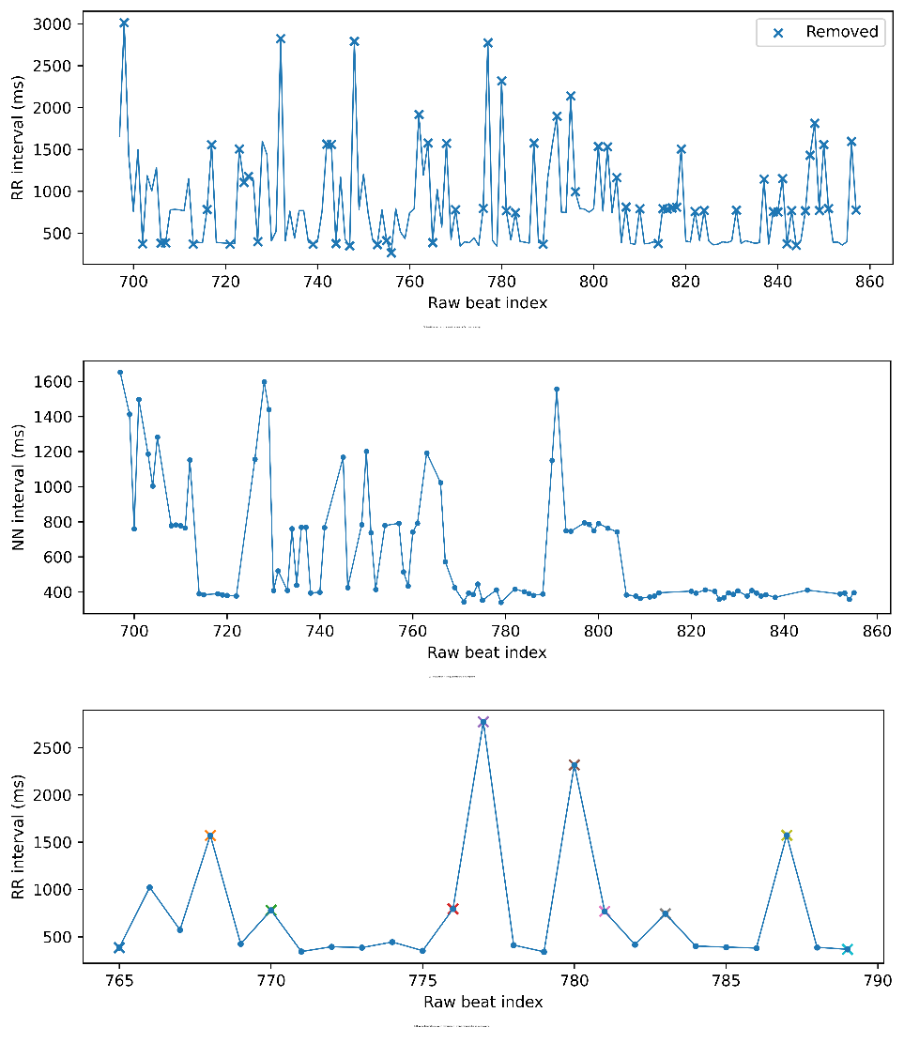
Supplementary Figure S1. Representative example of multistage RR interval preprocessing workflow. (A) Raw RR intervals from a representative recording segment, with observations removed during preprocessing marked by crosses. (B) Cleaned normal-to-normal (NN) intervals retained after multistage preprocessing and plotted at their original raw beat indices. (C) Enlarged view illustrating representative artifact removal during preprocessing. The initial 300–3000 ms range served only as a broad gross-error screen. RR intervals remaining within this range could still be excluded during the subsequent local-median or Hampel stages when they were inconsistent with neighbouring intervals.

Supplementary Figure S2. Sensitivity analysis of jump-specific Δpeak using alternative baseline and response windows. Spearman correlation coefficients between session order and jump-specific Δpeak calculated using three predefined baseline/response windows (30 s/20 s, 15 s/15 s, and 10 s/10 s). Shortening the analytical windows did not materially alter the overall interpretation of the longitudinal session-level patterns.

