Supplementary Material

Prompt Design for LLM Essay Scoring: From Rubrics to Calibration

This document holds the full rubric definitions, the complete scoring and judge prompts, and the metrics glossary referenced in the manuscript. The same materials, together with the data, model responses, and analysis code, are in the public repository.
Supplementary Section A: Rubric Definitions
The effectiveness rubric used in PERSUADE 2.0 defines three levels for each of the 7 discourse types. The table below summarizes the key criteria.

Supplementary Table S1. Rubric definitions: Effectiveness criteria by discourse type.
Discourse Type | Effective | Adequate | Ineffective
Lead | Grabs attention, strongly points toward position | Attempts to grab attention, points toward position | May not grab attention or point to position
Position | Clear stance closely related to topic | Addresses topic but may repeat prompt stance | Not relevant or no clear stance
Claim | Relevant to position, specific support, valid | Relates to position but may repeat it, moderate | Irrelevant to position, weak
Counterclaim | Reasonable, relevant objection to position | Not quite reasonable or not closely relevant | Neither reasonable nor relevant
Rebuttal | Directly answers and refutes counterclaim | Does not directly answer, not strong/valid | Misses the target, does not refute
Evidence | Relevant to claim, concrete facts/examples, sound | Not closely relevant, loosely bound examples | Irrelevant, few valid examples
Conc. Statement | Restates claims in different wording | Copies claims or restates only partially | Irrelevant to claims or misrepresents them

Supplementary Section B: Full Prompts
1. Baseline Prompt:
You are evaluating the effectiveness of a single discourse element from a
student’s argumentative essay.

Your task:
- Read the discourse element type and its text.
- Classify its effectiveness as one of: ineffective, adequate, effective.
- Provide a short feedback comment (1–3 sentences) explaining the rating
and how to improve.

2. Rubric-guided prompt:
You are evaluating the effectiveness of a single discourse element from a
student’s argumentative essay.

RUBRIC (argumentation effectiveness):
You are an expert essay grader. Assess the student’s argumentative writing using the following criteria. Each discourse element has three effectiveness levels: Effective, Adequate, Ineffective.
— Lead — Effective: The lead grabs the reader’s attention and strongly points toward the position.
Adequate: The lead attempts to grab the reader’s attention and points toward the position.
Ineffective: The lead may not grab the readers’ attention and may not point to the position.
— Position —
Effective: The position states a clear stance closely related to the topic.
Adequate: The position addresses the topic but generally repeats the prompt’s stance.
Ineffective: The position is not relevant to the topic, and/or it shows no clear stance.
— Claim —
Effective: The claim is closely relevant to the position and backs up the position with specific points or perspectives. The claim is valid and acceptable.
Adequate: The claim relates to the position but may simply repeat part of the position or state a claim without support. The claim is moderately valid and acceptable.
Ineffective: The claim is irrelevant to the position. It may also be weak and/or not acceptable.
— Counterclaim —
Effective: The counterclaim is reasonable and relevant. It represents a valid objection to the position.
Adequate: The counterclaim is not quite a reasonable opposing opinion, or it is not closely relevant to the position.
Ineffective: The counterclaim is neither reasonable nor relevant.
— Rebuttal —
Effective: The rebuttal directly answers and refutes the counterclaim.
Adequate: The rebuttal does not answer the counterclaim directly and it is not strong and/or valid.
Ineffective: The rebuttal misses the target. It does not refute the counterclaim.
— Evidence —
Effective: The evidence is closely relevant to the claim it supports and backs up the claim objectively with concrete facts, examples, research, statistics, or studies. The reasons in the evidence support the claim and are sound and well substantiated.
Adequate: The evidence is not closely relevant to the claim it supports. The evidence contains some detailed examples but they may not be relevant to each other and only loosely bound together. The evidence uses some unsubstantiated or unsound claims or assumptions.
Ineffective: The evidence is irrelevant to the claim it backs up and provides few valid examples. The evidence uses unsubstantiated assumptions that sound quite unacceptable.

— Concluding Summary —
Effective: The concluding summary effectively restates the claims using different wording. It may readdress the claims in light of the evidence provided.
Adequate: The concluding summary merely copies the claims or may restate only part of the claims.
It may partially misrepresent the claims.
Ineffective: The concluding summary is irrelevant to the claims. The conclusion may also misrepresent the claims.

Your task:
- Carefully read the rubric and apply it to the given discourse element type and text.
- You may give attention to the preceding text to understand the context of the discourse element.
- Choose the best-fitting effectiveness label: ineffective, adequate, or effective.
- Provide a short feedback comment (1–3 sentences) that references rubric ideas and helps the student improve.

3. Calibrated prompt:
You are an expert writing assessor using the rubric below to evaluate a
single discourse element from a student’s argumentative essay.

RUBRIC (argumentation effectiveness):
. . .
. . .

CALIBRATION (follow strictly):
- In practice, most discourse elements are rated adequate. Use effective
only when the element clearly meets the “Effective” criteria; when in
doubt, prefer adequate.
- Use ineffective only when the element clearly fails (e.g. irrelevant,
missing, or weak).
- For Evidence: require clear relevance to the claim and substantive
support; vague or loosely related support is adequate at best.
- For Rebuttal: require direct refutation of the counterclaim; indirect
or weak response is adequate.
- For Counterclaim: require a reasonable, relevant opposing point;
tangential or straw-man is adequate at best.
Your task:
- Apply the rubric to the given discourse element type and text, with
the calibration above in mind.
- Use the full essay only for context; rate only the specified element.
- Choose one label: ineffective, adequate, or effective. When uncertain,
prefer adequate.
- Provide a short feedback comment (1–3 sentences) that references
rubric ideas and helps the student improve.
Judge prompt (feedback comparison):

You are an expert writing assessor acting as an impartial judge of feedback quality. Use the rubric below as the gold standard. The human effectiveness score is the source of truth.

[RUBRIC: the same argumentation-effectiveness rubric as in Supplementary Section A.]

You will see: the full essay, the discourse type and text, the human effectiveness score, and two (score, feedback) pairs. The first pair is the Reference feedback; the second is the Evaluated feedback. Consider how well each feedback’s score aligns with the human score when judging quality.

Rate both pieces of feedback on four dimensions, 1 to 5 each: rubric alignment (how well the feedback aligns with the rubric), specificity (how specific and concrete it is), constructiveness (how constructive and actionable it is), and relevance (how relevant it is to the discourse element). Then choose which feedback is preferred overall (reference, evaluated, or tie) and briefly justify. Respond in JSON.

Hidden-label control: the predicted scores and the human label are removed, and the judge is told to judge only the feedback text.

Supplementary Section C: Metrics Glossary
Accuracy. The percentage of predictions that exactly match the human label.
Quadratic Weighted Kappa (QWK). Measures agreement between model and human while penalizing larger disagreements more heavily. Ranges from −1 to 1, where 1 = perfect agreement, 0 = no better than chance.
Cohen’s Kappa. Measures agreement beyond what random chance would predict. Unlike QWK, it treats all disagreements equally.
Macro F1-Score. For each label (Ineffective, Adequate, Effective), precision and recall are computed separately, and a per-label F1-score is calculated as the harmonic mean: F1 = 2 × (precision × recall) / (precision + recall). Macro F1 is the simple average of these three F1-scores. This gives equal weight to each label regardless of how many samples it has. A trivial classifier that always predicts “Adequate” achieves roughly 79% accuracy but only a Macro F1 of ~0.29, because it gets 0% precision and recall on the other two classes.
Mean Prediction Bias. The average difference between predicted and human scores (using Ineffective=0, Adequate=1, Effective=2). Positive = model scores too high (inflation), negative = too low (deflation).
Inflation Rate. How often the model assigns a higher label than the human grader.
Deflation Rate. How often the model assigns a lower label than the human grader.
Extreme Error Rate. How often the model is off by two full levels (e.g., predicting “Effective” when the human said “Ineffective”).
Supplementary Section D: Judge evaluation - baseline vs. calibrated feedback (DeepSeek-R1)

Baseline vs. Calibrated Feedback (DeepSeek-R1): Supplementary Table S2 shows the judge’s preferences when comparing baseline and calibrated feedback from DeepSeek-R1. Calibrated feedback was preferred 35.9% as compared to 17.7% for baseline (approximately a 2:1 ratio), with 46.4% ties. Mean score improvements across the four dimensions were: rubric alignment +0.281, specificity +0.236, constructiveness +0.194, and relevance +0.213.

Supplementary Table S2. Judge evaluation: Baseline vs. Calibrated feedback (DeepSeek-R1)
Preference | Count | Fraction
Calibrated preferred | 1,831 | 35.9%
Tie | 2,365 | 46.4%
Baseline preferred | 903 | 17.7%

Supplementary Table S2, Panel B. Mean score deltas (Calibrated minus Baseline).
Dimension | Delta (Cal – Base)
Rubric alignment | +0.281
Specificity | +0.236
Constructiveness | +0.194
Relevance | +0.213

Supplementary Table S2, Panel B shows that calibrated feedback scored higher on all four dimensions, and the largest gain was seen on rubric alignment (+0.281). The preference for calibrated over baseline is significant (chi-square goodness-of-fit against an even split, ignoring ties: χ²(1) = 315.0, p < 0.001).

Does the judge prefer better feedback, or does it just prefer correct labels? To understand what drove the judge’s preferences, we grouped the results by whether the two prompts agreed on the label as shown below in table 7.

Supplementary Table S3. Judge preferences by label agreement stratum (DeepSeek-R1)
Stratum | n (%) | Cal. Pref | Base. Pref | Tie | Action. Delta
Agree + match human | 1,623 (31.8%) | 13.7% | 23.2% | 63.1% | +0.006
Agree + miss human | 1,664 (32.6%) | 11.5% | 7.9% | 80.6% | +0.070
Disagree | 1,812 (35.5%) | 78.1% | 21.9% | 0.0% | +0.536

Note: Actionability delta = mean calibrated score minus mean baseline score on a composite 1-5 scale.

When both prompts produced the same effectiveness label and that label matched the human label (31.8% of cases, n = 1,623), the baseline was actually preferred more often (23.2% vs. 13.7%) and it had an actionability delta of just +0.006 (Supplementary Table S3 first row, stratum a). When the two prompts disagreed on the effectiveness label (35.5% of cases, n = 1,812), the calibrated prompt was preferred 78.1% of the time having an actionability delta of +0.536 which seems to be entirely due to calibration prompt having correct label more often than base prompt when there was disagreement between two labels. The judge’s preference depends on whether the two prompts agreed and matched the human label (chi-square test of independence: χ²(4) = 2891.3, p < 0.001).

Supplementary Figure S1 shows this relationship from a different angle. When grouped by the prompt’s label that was closer to the human rating, the judge’s preference closely tracked label accuracy. When calibrated is closer, the judge strongly prefers it. When baseline is closer, the judge prefers baseline. This reinforces that idea that label accuracy drives the judge’s overall preferences and not intrinsic feedback quality.

These results help answer research question 5. Calibrated prompting improves feedback quality ratings primarily because the label is correct more often, producing more relevant guidance. The 1.7:1 preference for baseline in label-controlled cases (Supplementary Table S3, stratum a) suggests that the calibration constraints may slightly reduce feedback richness even as they improve label accuracy and overall perceived quality.

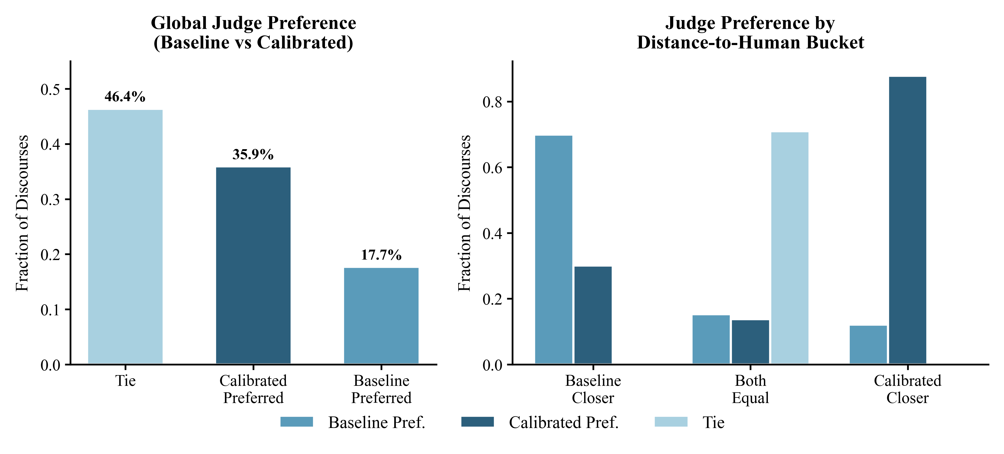
Supplementary Figure S1. Judge preference by which prompt's label fell closer to the human rating (DeepSeek-R1, baseline vs. calibrated).

